Nature for All – An organization dedicated to connecting people who are visually impaired or have other disabilities with outdoor opportunities.
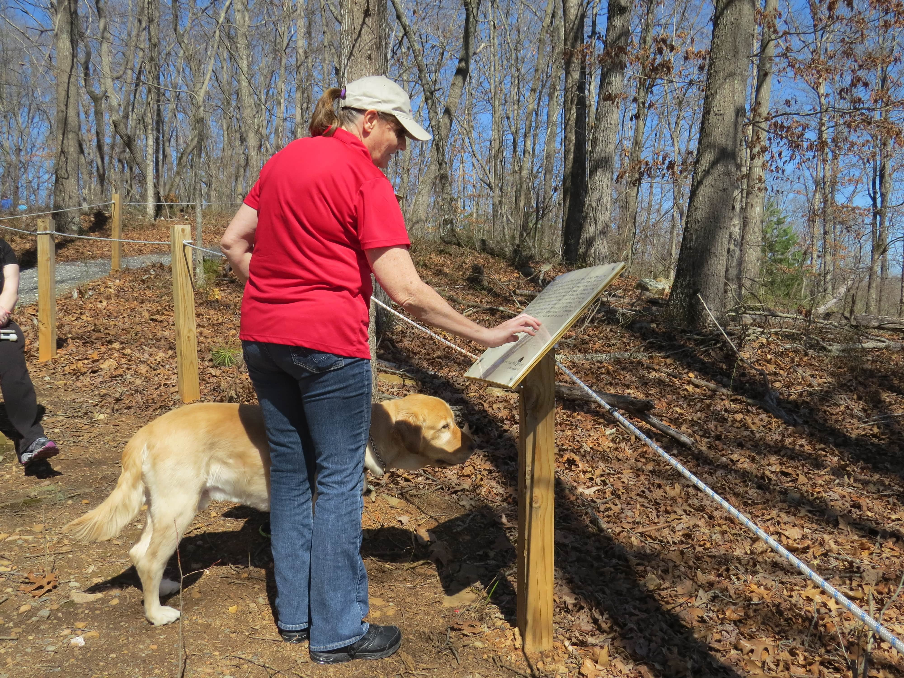
Source: http://www.naturefortheblind.org/what-is-a-braille-trail

Founded by Evan Barnard, Nature for All is an organization dedicated to connecting people who are visually impaired or have other disabilities with outdoor opportunities and promoting the development of inclusive and sustainable cities worldwide. Nature for All’s website and its page dedicated to promoting sports opportunities for people with disabilities at http://www.naturefortheblind.com/sports-for-the-blind
With opportunities for people to engage in sports activities at recreational, team, national, or Paralympic levels, this page lists contact information for over 20 different types of adaptive sports and national sports organizations from over 100 countries for people with visual impairments and other physical disabilities.
An important part of Nature for All's work has been the establishment of the website www.naturefortheblind.org, which has a directory of over 200 braille nature trails and sensory gardens in 37 countries so people who are visually impaired or have other disabilities can enjoy nature experiences near where they live. The website also contains information on educational resources, sports, assistive technology, travel opportunities, and more. In its first year, the website was visited by viewers in 58 countries and translated into 47 languages with over 10,000 page views. CNN's Great Big Story created a short film about Nature for All, which has already been viewed online worldwide over 250,000 times. Please watch and share this link: https://www.greatbigstory.com/stories/leading-the-blind-the-student-helping-the-blind-experience-nature
Nature for All also created a Facebook page at www.facebook.com/naturefortheblind, which features links to nature opportunities, sports, articles about education programs and adaptive technology, and stories about successful people and programs. Please assist these efforts by liking, following and sharing our Facebook page.
Promoting the United Nations' Sustainable Development Goals for inclusive and sustainable community development, Nature for All was one of 50 youth-led projects internationally featured in the UN's inaugural Youth Solutions Report (http://www.youthsolutions.report/the-report, page 55). The UN’s commitment to creating inclusive communities and providing more opportunities for people with disabilities to experience the outdoors is phenomenal for people around the world who have disabilities and those who work to support them. Nature for All has recently been accepted as one of the UN’s Sustainable Development Solutions Network youth partner organizations and will continue to advocate for inclusive opportunities for people with disabilities around the world.
For further information, questions, or suggestions for the website, please contact Evan Barnard, Founder and President of Nature for All at evan.barnard@nature4all.org
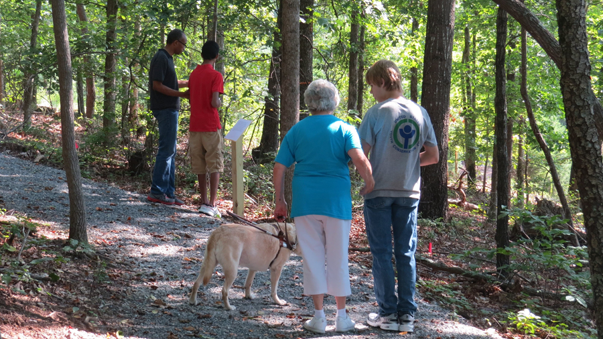
Source: http://www.naturefortheblind.org/advocacy

