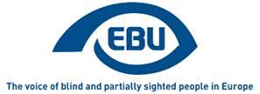

EBU Members' Newsletter

Number eight, September 2020.

Editorial
Dear readers of our monthly newsletter,
This year is in many ways not “business as usual”. The outbreak of the pandemic and the ongoing fight against the spread of the virus are having an impact on our work at all levels. And while this means adapting our plans all the time, especially when it comes to face-to-face meetings and events, it also offers opportunities such as an increased use of virtual platforms allowing a greater number of people to come together. In this context of uncertainty, and six months after my arrival at EBU, I would like to highlight the following points, as I also look at the final stretch in 2020:
• On the COVID topic, I am glad to announce that EBU has released its position paper in September. This paper targets both decision-makers and the general public, so it is designed as an awareness-raising document. I hope many of you will find this tool useful and help us with translating it into as many languages as possible. Thanks to our friends in Montenegro who have already done so! Please let Gary (ebuinfocom@euroblind.org) know if you plan to translate and share the translated versions with him, so we can also publish them on our website.
• As many of you know by now, we had to cancel our annual conference and most likely the meeting of the Liaison Commission in their initially planned format. But this does definitely not mean that they will not take place: both gatherings will be replaced by interesting online sessions and the details will be shared with you shortly. I’d like to thank all those who are investing their time and effort in adapting the programme of those meetings to the new reality.
• One of our many project activities rewards every year best practices at the national level on a given topic. This year, we looked at accessibility of websites, focusing on the public sector. Whilst thanking those who contributed and whilst congratulating the three prize winners, from Italy, Poland and the Czech Republic (ranked from 3rd to 1st place), I also would like to underline that the participation in this contest was extremely weak. And this despite the uncontested relevance of the topic at stake. I very much hope that this is due to the challenging context of COVID, and not a general trend of low participation in our various project activities, which can only live based on the members’ involvement.
As you will further read in this newsletter, a lot is happening in the area of advocacy and campaigning with great achievements such as on a European Parliament report on employment!
I hope you will enjoy reading this newsletter and share your news items with us for upcoming editions.
By Lars Bosselmann, EBU Executive Director

OUR CAMPAIGNS

Creative Europe/MEDIA
We finalised the EBU position paper on MEDIA funding to the European film industry: Promote Equal Access to Culture for Persons with Visual Impairments in the EU. This constitutes the first major development of the campaign for equal access to culture. In this paper, we argue that MEDIA must contribute to the awareness of audio description and audio subtitling among film producers as an element of accessibility for blind and partially sighted persons, and suggest how.
Considerable exchange, namely, at EU level, with the European Commission, the European Parliament rapporteur, EACEA (the Executive Agency that manages the MEDIA funding) and EFAD (the European Association of Film Agencies), but also at national level in Germany, have fed into our position paper and into a dedicated edition of our Focus Newsletter to be published in October.

Accessible lifts
We continued our work, in liaison with ANEC and EDF, to fine-tune our recommendations ahead of the next meeting, in early October, of the CEN/TC 10/WG 7, the EU standardisation body’s working group that is revising the accessible lifts standard.

Miscellaneous
• We continued to be consulted, together with other DPOs, by MEP Katrin Langensiepen, on her report for the European Parliament on the implementation of the Employment Equality Directive in light of the UNCRPD, up to the presentation of her draft report to the EMPL Committee. The contribution of EBU is acknowledged in the report, which we intend to support through communication as good practice in response to our demand: “nothing about us without us”.
• We participated in the EU vs Discrimination campaign closing seminar, on 11 September. On that occasion, the Commission presented “How to put reasonable accommodation into practice — guide of promising practices”, for the implementation of the Equality in Employment Directive.
• We responded to the Commission’s public consultations, respectively on the European Democracy Action Plan, and on the future sustainable mobility strategy (in the latter case essentially to echo and support the EDF response).
• We forwarded to our member organisations in the EU the EDF toolkit for the transposition at national level of the European Accessibility Act, and attended their webinar presenting the recommendations therein contained.
• We participated in the EDF-ENGO meeting of 17 September, where information was exchanged about reaction to the COVID-19 crisis as it affects persons with disabilities.

The 25th EBU Access Cast is now online!
Welcome to the 25th transcribed episode of the EBU Access Cast - podcast about assistive technology for blind and partially sighted people!
The European Commission and the European Disability Forum organised on 23 September an online WEBINAR on the web accessibility directive marking this important date by which all public sector websites across the EU will have to be accessible for persons with disabilities.
If you attend often online events via Zoom and if you would like to adjust the verbosity of the events the new NVDA addon for Zoom can help you to enhance your Zoom experience. If you would like to separate the screen reader from the other sounds on your computer, you can do this by using Audiomixer by the Dutch company Babbage.
Have you noticed that the native Facebook website became screen reader accessible? Engineers from Facebook explain how they built accessibility into the new Facebook interface
Microsoft opened the Accessibility Fundamentals training to everyone. The course is composed of 4 modules that give a basic understanding of accessibility in Microsoft products.
Android 11 has been launched and we commented the new accessibility features. The Google Lookout app has been updated and now Android users can benefit from having a similar application as Seeing AI on iOS. Pawel prepared for you a demonstration so stay tuned until the end of our episode to hear how it works. Google Chrome started to generate accessible PDF documents by keeping the HTML structure from the saved webpage.
Libre Office 7.0 introduces accessibility checkers for documents. Wondering how to wash or iron a shirt? Laundry Lens is the app that can read care labels on clothes to determine the washing conditions.
Lego Braille Bricks, a set of bricks for children to learn Braille, launches in a couple of European countries. We also announced the new virtual event, Sight Tech Global which will be organised on the 2 and 3 December 2020.
Watch this space for the next episode where we'll be sure to deliver even more exciting news. Meanwhile, feel free to reach out with your thoughts and suggestions through our Email and Twitter.
For more on this and much more useful information, go to the podcast page!

Montenegro - monitoring of the application of guidelines for creating electronic documents
The Union of the Blind of Montenegro, in cooperation with the Ministry of Public Administration, conducted the monitoring of the application of guidelines for creating electronic documents, in line with e-accessibility standards, through 21 websites of Montenegrin institutions and 208 documents.
The monitoring was conducted by blind and partially sighted persons, in accordance with the methodology and questionnaires created in relation to the elements of accessibility for blind persons, screen readers and partially sighted persons, contrast, font size and page layout.
Although there exists a document that regulates e-accessibility since 2017, it has been stated that the situation is not encouraging.
Some of the key results:
- 100%, keyboard navigation customized
- Alternative text to non-textual content can be read by the program for screen reading in 71,34% of cases.
- The possiblity to increase the font and entire page is possible in 66,67% of cases.
- The possiblity to adapt the contrast of the background and letters on the page is possible in 61,9% of cases.
- There are no subtitles or transcripts of non-textual content.
- Pages consisting of scanned documents are partially avoided.
- There is no automatic conversion of text to audio format
A detailed analysis, as well as the recommendations for improving the situation were given within the document. The analyis is distributed to all the institutions that were a subject of the monitoring, which are expected to work on better e- accessibility.
The Ministry of Public Administration has announced the development of a new website for institutions of the Government of Montenegro, in compliance with the Guidelines and conclusions of the monitoring.

Belgium - Discrimination at work
Brailleliga/Ligue Braille launches a new campaign about employment on September 21. The title of the campaign is: “Can you see my talents?” According to the 2019 annual report of Unia (Belgian center against discrimination), disability discrimination lists as the second most frequent cause of work floor discrimination.
This campaign has a double goal, first we want blind and visually impaired people to know that Brailleliga/Ligue Braille can help them with questions and problems concerning employment. Second we want to raise awareness about the capabilities of visually impaired people who received tailored guidance.
The specialized teams of Brailleliga/Ligue Braille help blind and visually impaired people to overcome all obstacles on their way to employment. Some examples are the prejudices, the mobility, the adaptation of the workplace and the insufficient knowledge of the disability. Thanks to their multidisciplinary approach and many years of experience, the specialized services of the Brailleliga/Ligue Braille are the right experts to guide blind and visually impaired people in their search for employment.

NCBI Secures Covid-19 app is Accessible!
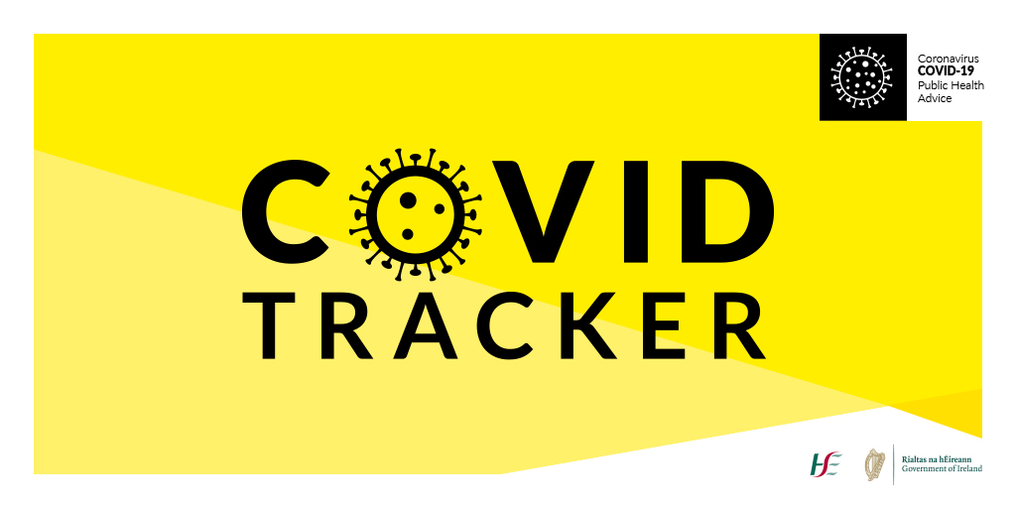
Thanks to the involvement of the NCBI Advocacy department and NCBI Labs, Ireland has one of the most accessible Covid-19 tracking apps in the world. The advocacy team contacted the HSE in late April on learning of the app being developed stressing how important it would be to ensure the app was accessible to people who are blind and vision impaired.
A number of NCBI advocates raised this issue with the HSE and the Government also. These actions resulted in the HSE considering the needs of people who are blind and vision impaired and them acquiring the expert services of NCBI Labs who worked closely with the app developers to ensure the app was fully accessible to our community.
What is it?
Launched by the HSE and Department of Health on Tuesday 7th July, the Covid Tracking app will help us to protect each other and slow the spread of Covid 19 in Ireland. It is a free and easy to use app available from the App Store and Google Play Store that has three specific functions:
- Digital contact tracing of close contacts of confirmed cases of Covid-19
- Allow users to record if they have symptoms
- Provide daily information about Covid-19 from a trusted source
How does it work?
Once you open the app, you will be asked for permission to collect and share anonymous data in order to facilitate contact tracing. You also have the option to add your phone number so the HSE can contact you if you are thought to be in need of a test. It should all take less than two minutes, and you're up and running.
NCBI would encourage as many of you as possible to download the app and join in Ireland’s fight against the virus.

Brailleliga/Ligue Braille BrailleTech fair
From 13 to 17 October, Brailleliga/Ligue Braille organizes its yearly BrailleTech fair. Due to the Covid-19 situation, our 2020 edition will be a little different: we will organize both a ‘Live BrailleTech’ and a ‘Digital BrailleTech’.
Join the exhibition in our head office and discover a wide range of technical aids that make life easier for visually impaired people. This includes simple items that are used on a daily basis but also more complex devices, which require special training. 7 Belgian suppliers will be present at BrailleTech, making it a unique opportunity to try out and compare existing products and innovations.
For the first time, we will also offer a digital BrailleTech. Attendees will be able to learn more about different kinds of technical aids during videos, videoconferences and webinars. The complete schedule (in Dutch and French) is available.
Visitors need to subscribe in advance, please visit www.braille.be and register. Pay BrailleTech a (virtual) visit and discover much more!

This sponsored content is provided by Mattel

UNO®, the number one card game
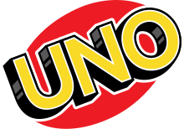
UNO®, the number one card game globally* by Mattel announces the European debut of UNO Braille, the first official UNO card deck featuring braille The new game will make game play widely accessible for blind and low-vision people across Germany, Spain, Italy, France, Switzerland, Belgium and Netherlands. This launch follows the entry into the US market in late 2019 with the National Federation of the Blind and represents another step towards a significant portfolio of diverse and inclusive Mattel products.
UNO Logo
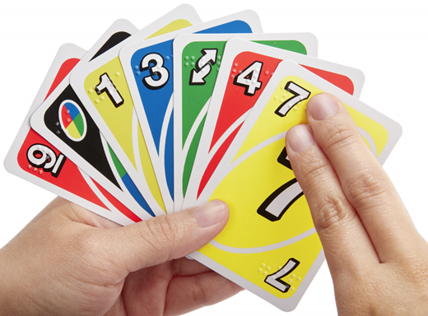
Official UNO card deck
UNO Braille presents in the corner of each card the necessary Braille writing to indicate the colour and number or action of each card, which allows all people to play together, inclusively, independently whether or not you have a severe visual impairment.
Throughout 2020, UNO Braille is being co-launched with a number of key European national associations of the blind, such as Spanish ONCE and French Association Valentin Haüy (AVH).
UNO Braille is available throughout retailers across Germany, Spain, Italy, France, Switzerland, Belgium and Netherlands, with prices around €15.99.
ENDS.
European Blind Union
6 rue Gager Gabillot, 75015 Paris, France
+33 1 88 61 06 60 | ebu@euroblind.org | www.euroblind.org

