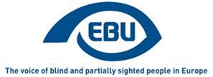

EBU Focus Number twelve, February 2021.

Acoustic Systems for Information and Navigation.

Three more language versions now available!
EBU Focus newsletters are now available, as word documents only, in Polish, Serbian and Turkish. We hope that these translations will enable this information to reach a wider audience.

Following up on the EBU 2020 Webinars - Acoustic Systems for Information and Navigation
By: Ing. Josef Sögner, Austrian Federation of the Blind and partially sighted (BSVÖ)

Learning and Outlook
The above mentioned Webinars for Acoustic Systems for Information and Navigation , held on the 10, 18 and 27 November 2020, brought together a wide variety of experts – both from Institutions within the EBU, but also developers from an organization for the visually impaired, as well as manufacturers, who have been working in that field for years, and thus have detailed knowledge of what the real needs of our communities are.
We have a long history of acoustic systems supporting visually impaired people in everyday life to a certain extent – depending on the complexity of components installed.
On the other hand we realised in recent years that our communities were asking for a more inclusive approach making “inclusion” a reality. As it turns out a Smartphone seems to be the first choice for nearly all offerings in that matter. This obvious choice does have a downside, as a fair share of blind and partially sighted people don´t have a Smartphone or are not fully able to use such a device.
Being aware of that, Okeenea (a French manufacturer) informed us of their solution. By means of a new device called “aBeacon” – an intelligent, acoustic box – and a remote control with Bluetooth, or an app on a smartphone, all known obstacles at complex crossings can be overcome, they claim. It is very important to note that this solution is designed to work with existing and older acoustic traffic lights from other manufacturers. This is a major aspect, because, as we all know, limited budgets are the main reason for slow progress in achieving “inclusion” for blind and partially sighted people.
This is one example how a solution from one country – France– is able to offer a path for more inclusion throughout Europe. Existing components with national standards in use for decades do not seem to offer a path to the future. Basing things on an industry standard – e.g. Bluetooth – rather than national or European Standards might be a promising approach for the future.
Adding more and improved features to existing acoustic components doesn´t sound as expensive as starting from scratch. We learned further on that specific navigation apps for the blind and partially sighted people are available – both outdoor (GPS-based) – as well as indoor (beacon based).
Products have been developed for public transport services – both a solution depending on a one system supplier (Swiss Federation of the Blind and Visually Impaired with Trapeze) and an independent solution working with every system supplier for public transport services (Geomobile). The big difference is: the price! Therefore we see a very slow pace of buses and trams introducing the solution of Geomobile in Germany.
The masterpiece, a seamless journey from door to door, hasn´t yet been made possible, but the solutions necessary for this endeavour are available. Again, cooperation amongst various manufacturers might be the only solution in order to keep development costs down and therefore make installation costs feasible.
To sum up, there is a very obvious conclusion, which we may lose sight of in daily business:
The urge is local, the solution is European (even worldwide)!

AVAS – how to move from successful legislation to successful implementation and what are the next steps
By Prof. Ercan Altinsoy, Chair of Acoustic and Haptic Engineering, Technische Universität Dresden
Hearing is an important sense in our daily life and enables us to interact with our environment, objects and other persons. The sound signals deliver us several information. Therefore, hearing and vehicle sounds play an important role for the traffic safety. The timely detection of the vehicles by pedestrians is a prerequisite. However, electric vehicles move almost silently up to a speed of 20 km/h. In order to reduce this risk for all traffic participants including especially children, visually impaired and elderly persons, and cyclists, quiet vehicles should emit artificially generated sounds. For this purpose, standards have already been defined by various national and international authorities with regard to the sound character. The regulation of United Nations Economic Commission for Europe (UN Regulation No. 138 - ECE/TRANS/WP.29/2016/26) and US, Federal Motor Vehicle Safety Standard (FMVSS) 141 are two of the most prominent.
The legislations define the minimum A-weighted sound pressure level per 1/3-octave band. Although the results of several scientific studies were taken into account to prepare the above mentioned standards, we will experience in the following years if the required sound pressure levels will guarantee the intended traffic safety. To gain experience with the defined minimum sound level requirements particularly at very noisy traffic situations is very important. All car manufacturers and suppliers developed successful technical solutions for the implementation of AVAS. At the same time, some technical problems will still be important in the near future. Some of these technical problems are the speaker directivity characteristics, speaker frequency response and sensitivity variations and the placement of the speaker. However the most important aspect is the sound design.
Car manufacturers design individual warning sounds taking into account the defined minimum sound pressure level and frequency requirements. Some of these warning sounds can be easily recognized as a vehicle sound by pedestrians and people and some of them cannot. Some of these sounds inform pedestrians about the operating conditions, such as velocity, acceleration, deceleration, with great success and some of them don’t. Another important topic is the environmental impact. The sound design plays an important role on the perceived annoyance of the warning sounds. Some of these warning sounds can be very annoying for residents.
Over the following years, the society will have the chance to evaluate the perceived annoyance of different warning sounds. The least annoying warning sounds will be preferred by drivers and at the same time by car manufacturers. This will lead to the warning sound design gradually being less unpleasant. The EU Project eVADER and several research groups, including my own, try to improve the technical implementation solutions and the regulations. A possible modification of the standard can include the automatic adaptation of the AVAS level depending of the background noise. Another important future aspect is the detection of pedestrians and emitting a directional sound beam only in the direction of pedestrians to avoid unnecessary noise pollution.

MyWay Pro - A Platform for Inclusive Navigation
By Luciano Butera, Swiss Federation of the Blind and Visually Impaired SFB
The Swiss Federation of the Blind and Partially Sighted SFB launched the app MyWay Pro, an orientation and navigation app optimised for visually impaired people.
The app is a successor of MyWay Classic using state of the art navigation-technology. Together with a growing group of test-users SFB identified the needs of blind and partially sighted users and launched the first release after two years of development in June 2020.

MyWay Pro has the following main features:
- Record and edit individual routes either manually or automatically
- Calculate a route to an address using the service of Apple Maps
- Exchange of route files in OSM, GPX and PLIST formats
- List- or map-based presentation of selected route and possibility to edit it
- Turn by turn navigation
- Frequent acoustic distance and direction updates during navigation in background (either after a fixed time or after walking 1/3 of the distance to the next point of the route).
- Locate the direction to the next point continuously by holding the mobile device flat and turning it around until a beep marks the direction.
- Show of nearby Points of Interest like restaurants, traffic lights and crossing.
- Start the navigation to a POI.
- MyWay Pro is highly customizable
The ability to announce nearby crossings when the app is running in background is just a first feature. SFB plans to add regularly new features which improve the orientation and navigation of blind and partially sighted users.
The App is available in Apple's App Store (Europe area) and runs on IOS 11.2 or later. “MyWay Pro” can be downloaded from the App Store as a subscription service. The subscription costs EUR 0.99/month or EUR 9.99/year. As an alternative the app can be unlocked for lifetime use for a one-off payment of EUR 33.99. The subscription model allows to test the full version of “MyWay Pro” for free for one month.
The App and its main Functions work everywhere. There are two main limitations.
- As of today, the app is just available in German, French, English and Italian.
- The App uses OpenStreetMap (OSM) for the presentation of Points of Interest in the surrounding. The Quality of OSM is not constant around the globe. Some data is not available, some is not up-to-date and some is just coded differently. We try to extrapolate the most useful information of the data but currently our tests are limited to Switzerland.
To improve the quality of the service in more regions we need the support of local volunteers. If you are interested to improve the App in your region, we are happy to work together with you. We can offer a test-environment, which gives you an early access to the newest features. If you just want to give feedback you can contact us through the app or write an email to tech@sbv-fsa.ch.
Youtube-Video (English Version)
https://www.youtube.com/watch?v=gTnrA9rQLiw
App-Store-Link
https://apps.apple.com/ch/app/myway-pro/id1434398223
App-Store-Icon
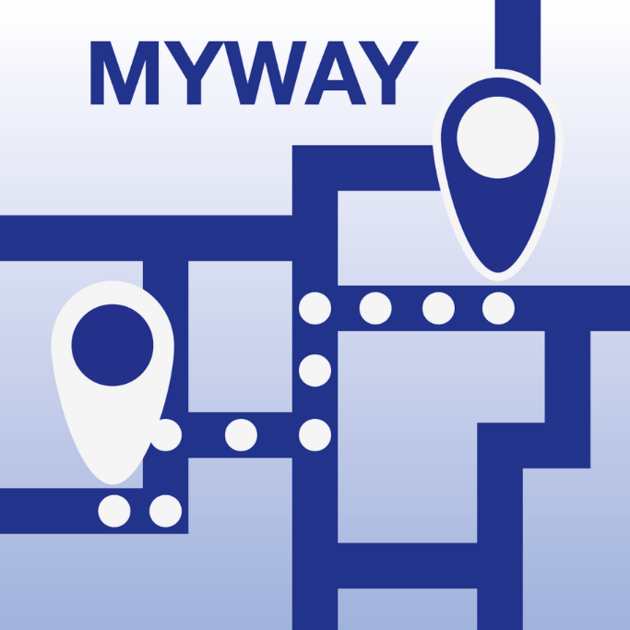

How do you like Iceland?
By Hlynur Þór Agnarsson, Accessibility consultant
Blindrafélagið, Icelandic Association of the Visually Impaired
hlynur@blind.is
Blindrafélagið, the Icelandic Association of the Visually Impaired, has been looking into many different options in the past year regarding navigation and wayfinding solutions. This includes bluetooth beacon solutions with 3D mapping, audio beacons, tactile guidelines, NaviLens markers and other similar solutions.
When it comes to audio navigation, Iceland is far behind many other European countries. There is a great lack of legal obligations to implement audio beacons or other similar devices, for example at intersections and building entrances. Just recently, some of Iceland‘s largest municipalities started placing tactile warning studs and plates near bus stops and intersections as well as occasional guidelines outdoors.
As bad as the situation may be, we try to look ahead and focus on what we can do to change how these constructions are planned and carried out. Talking and working with government officials and others involved, we try to have an impact for the better. Even though this is a marathon, not a sprint, hopefully with time all newly built and restored structures will be accessible to everyone.
In early 2011, audio devices were installed in all buses in Iceland‘s capital region, announcing next stops for passengers on board. This was of course a great step in the right direction and as an inclusive solution, it works for everyone, not only the blind and visually impaired. In fact, general usage of public transport by blind and visually impaired people is very low compared to other countries. This may be due to the lack of quality of the public transport system, but a major factor is without a doubt a very good transport service for the blind and visually impaired, provided with collaboration of Icelandic municipalities, the Icelandic Association of the Visually Impaired and Icelandic taxi companies. This means that blind and visually impaired people in Iceland, given that they live in a municipality that has a service contract of this sort, can order a taxi in the same way as everyone else, but only pay a fee that equals 1 fare with public transport. This service has evolved over time since it was established in 1997, and now people living in many of Iceland‘s urban areas get to use this service within the Reykjavík area with support of their local municipality. This system is something we are very proud of, but it is no excuse for the lack of general accessibility for blind and visually impaired pedestrians that has been the case for many years.
As we are a nation of around 370.000 people with our own language, our small size has often been an obstacle when it comes to new technology solutions. Many of those who are using some kind of audio guidance must do so in English or one of the other major languages. But with visual impairment generally increasing as we grow older, many who are blind or visually impaired and are not confident using another language tend to get left out. The great advances in accessible technology in recent years have therefore not been available to them. There is, however, a government project currently in process which we hope will resolve this issue and encourage companies all around the world to include the Icelandic language in their own products, both to be spoken by them as well as spoken to them.
ENDS.
European Blind Union
6 rue Gager Gabillot, 75015 Paris, France
+33 1 88 61 06 60 | ebu@euroblind.org | www.euroblind.org

