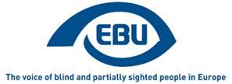

# EBU Members' Newsletter 2021

## Number Eight, September.

## OUR CAMPAIGNS

### Creative Europe/MEDIA

In the second week of September, as part of the PARVIS project, we had an awareness-raising campaign on Twitter about the right of access to culture, in which we particularly highlighted the need for audio description and audio subtitling for the enjoyment of films by BPS people, and our related demands as regards public funding to the film industry.

### Marrakesh Treaty

The European Commission published a [Summary Report](https://ec.europa.eu/newsroom/repository/document/2021-25/Factual_Summary_Report_Targeted_Consultation_Marrakesh_Directive_AeRCcMvag1wCcgnJnOdjEYYC78_77439.pdf) on its targeted consultation on the availability of accessible-format non-print works within the internal market, which aimed to see whether there was scope for extending the copyright exemption under the Marrakesh Treaty Directive to other types of works and/or disabilities.

Jointly with EDF, we expressed concern about the paragraph reading: “Stakeholders representing cultural heritage or educational institutions and those representing the interests of persons with disabilities mostly expressed their preference for producing ‘accessible format copies’ themselves rather than acquiring already commercially available accessible formats.”

We argued that:

* It sends the wrong signal to producers and undermines the efforts made by the EU in setting a legal framework to ensure that products, services and content are accessible by default, namely through the European Accessibility Act, the Web Accessibility Directive and the Audiovisual Media Services Directive.
* A potential copyright exemption to increase the availability of accessible content would be beneficial, but this should not imply that the responsibilities and the provision of this content should be placed on specialised entities only.
* Because the consultation, in many questions, appeared to target at organisations that produce their own material, has not have given sufficient visibility to the point of view of organisations representing persons with disabilities, let alone of individual persons with disabilities.
* In any case none of the organisations (only 6) that indicated they preferred to produce ‘accessible format copies’ themselves are DPOs, and that the report should indicate that DPOs, for one, clearly mark a preference for the possibility of acquiring already commercially available accessible formats.

### Accessible lifts and other standards

The technical revision (EN 81-70:2021/prA1) of the Accessibility to lifts standard EN 81-70:2018 was adopted, which now provides for satisfactory colour contrast requirements. This is the result of ANEC representations within the relevant working group of CEN, in which EDF and EBU were closely consulted.

### Reform of EU electoral law

Recommended amendments to improve the European Parliament’s own initiative report to further harmonise the electoral system and procedure applicable to European elections, have now been sent by EDF to the rapporteur of the Constitutional Affairs Committee. We stand ready to act in support, upon EDF request and coordination.

### Miscellaneous

European Accessibility Act

We contributed to EDF and ANEC comments to the European Commission on a draft standardisation mandate for the implementation of the EAA. We particularly focused, in direct comments of our own on e-books (jointly agreed with EDF and the Daisy Consortium), to say this in substance:

We do not object to e-books being excluded from the mandate, i.e. going through the route of technical specifications, on condition that it is ensured that current industry standards are effectively fit for purpose. For this, we recommend to the European Commission to ensure, before issuing the final standardisation request, that the technical specifications for e-books refer to the EPUB Accessibility Conformance and Discoverability Requirements 1.1, as argued by the EPUB Accessibility - EU Accessibility Act Mapping.

Connecting Europe Express

In the context of the European Year of Rail 2021, EBU was invited to hop on board of a ‘Connecting Europe Express’ train from Rome to Milan through Genova, on 7 September, to meet with the Executive Director of the Community of European Railway and Infrastructure Companies (CER) and discuss availability for BPS people. Francesca Sbianchi of UICI kindly represented us on that occasion.

Consultations

We responded to the following two European Commission consultations:

* the [public consultation on a set of European Digital Principles](http://www.euroblind.org/sites/default/files/documents/response_to_consultation_on_a_set_of_european_digital_principles_aug_2021.pdf)
* the targeted [consultation on improving the SDG monitoring report](http://www.euroblind.org/sites/default/files/documents/response_to_consultation_on_improving_sdg_monitoring_report_sept_2021.pdf)

We have signalled again to our members the [public consultation on the implementation of the Web Accessibility Directive](https://ec.europa.eu/info/law/better-regulation/have-your-say/initiatives/12537-Accessible-web-&-digital-content-for-people-with-disabilities-review-of-EU-rules/public-consultation_en), the which deadline has been extended to 21 October.

And we also signalled the EDF survey on BPS people’s experience with online voting tools, indicating that feedback would also be useful input to our AVA project (Accessible voting Awareness-raising).

Events

We attended the following events:

* EDF e-workshop on the EU Disability Card (16 September)
* EDF-W3C open meeting on the Web Accessibility Directive (28 September)

EU Roundtable on Equality Data (30 September)

## Report on a pilot workshop on autonomous buses within the PAsCAL project

On September 20th 2021, Romain Ferretti, EBU Project Manager, and I participated in a pilot study on connected and autonomous buses in Luxembourg. The study was carried out by the project partner EBUS of the [PAsCAL research project](https://www.pascal-project.eu/), co-funded by the European Commission. There were 6 blind and partially sighted participants from DBSV (Germany), including the chairperson of the commission for environment and mobility, Eberhard Tölke as well as some personal assistants.

The pilot study concentrated on the acceptance of autonomous busses by blind and partially sighted persons. It was part of a very broad study on driver assistance features up to completely autonomous driving cars and busses. For EBU it is very important to participate in this kind of projects as we can influence the development of this future technology and point out the needs of blind and partially sighted persons.

A picture showing the autonomous bus with ‘Pascal’ displayed as a destination. (Photo Romain Ferretti)

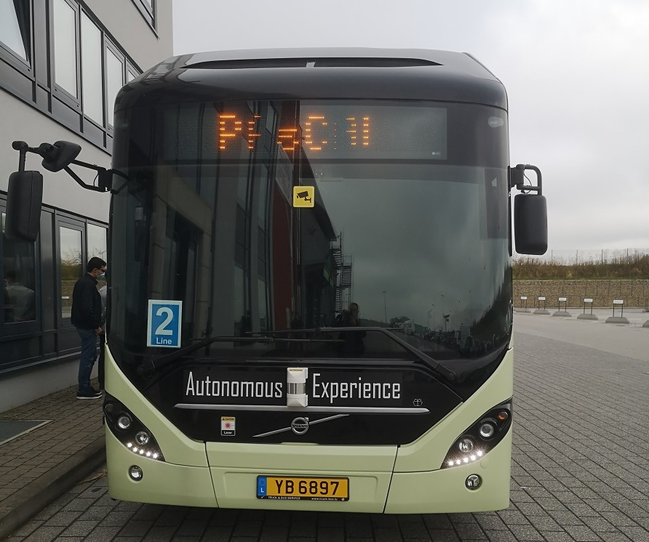

During the Luxembourg pilot study the participants were asked to take part in two bus rides. The first one with a conventional diesel bus and the second one with a Volvo Hybrid 7800 Bus, that was programmed to work only in the electric mode during the pilot. The bus was modified, so that the participants could not have any contact with the driver by an additional wall in the bus which carried a screen giving visual information on the ride. Additionally there was acoustic information about the regular bus stops, additional stops that were not scheduled, a high speed section of the trip, as well as door-opening and -closing. For sighted participants of the study there was additionally a tablet computer placed on the window left of the door with four functions to be initiated by touch.

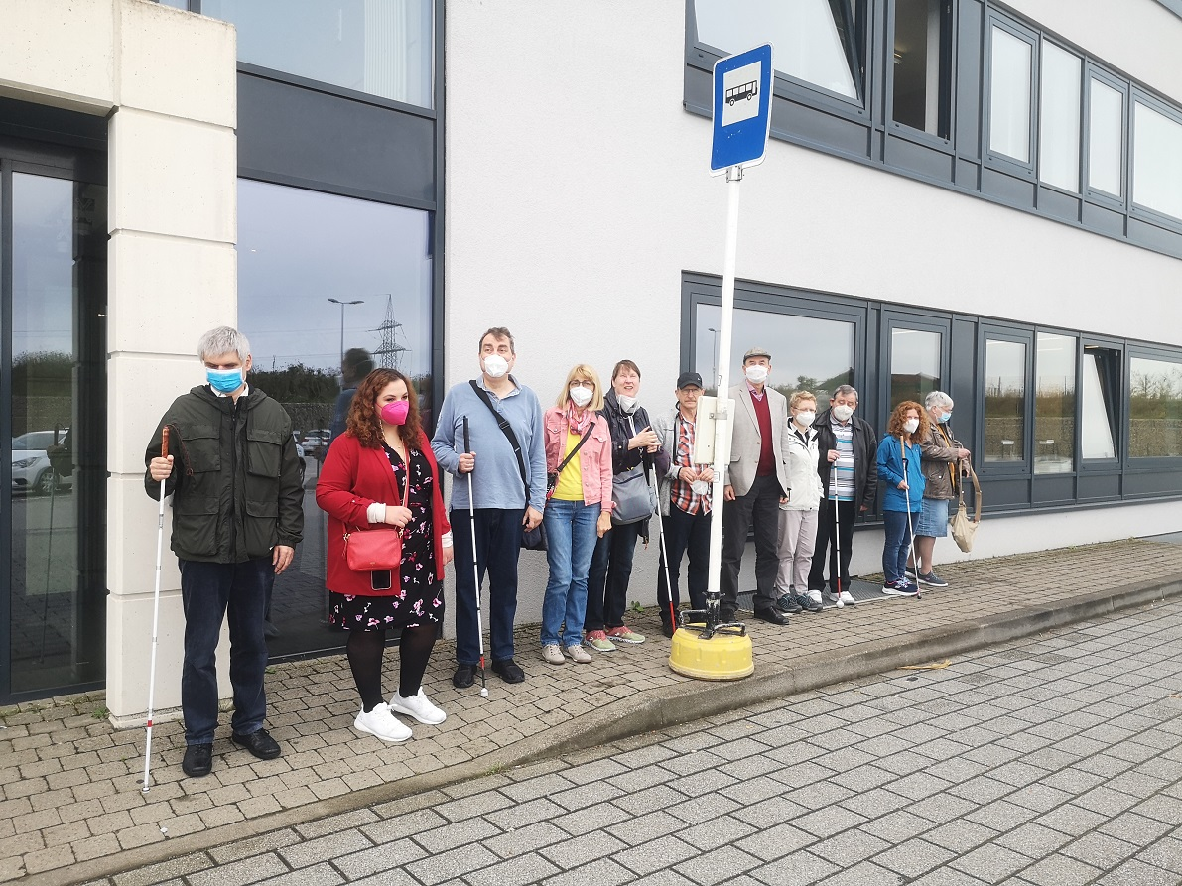

A mixed group of participants, some with white canes, waiting at a bus stop. (Photo Romain Ferretti)

After the two rides the participants were asked to answer a questionnaire of 37 items to describe the experiences and attitudes with regard to autonomous and connected cars and busses. Then there was a focus group discussion which concentrated on the emotional experiences of the participants. It turned out that all participants felt safe during the ride and would not have any reason not to trust in an autonomous system that functions like that. But the participants had a lot of technical recommendations to improve accessibility and usability of future autonomous busses. Most of those we already had collected by EBU’s Road Safety and Access to Transport network independently, but from a theoretical point of view.

A mixed group of participants, some with white canes, travelling on the bus (Photo Romain Ferretti)

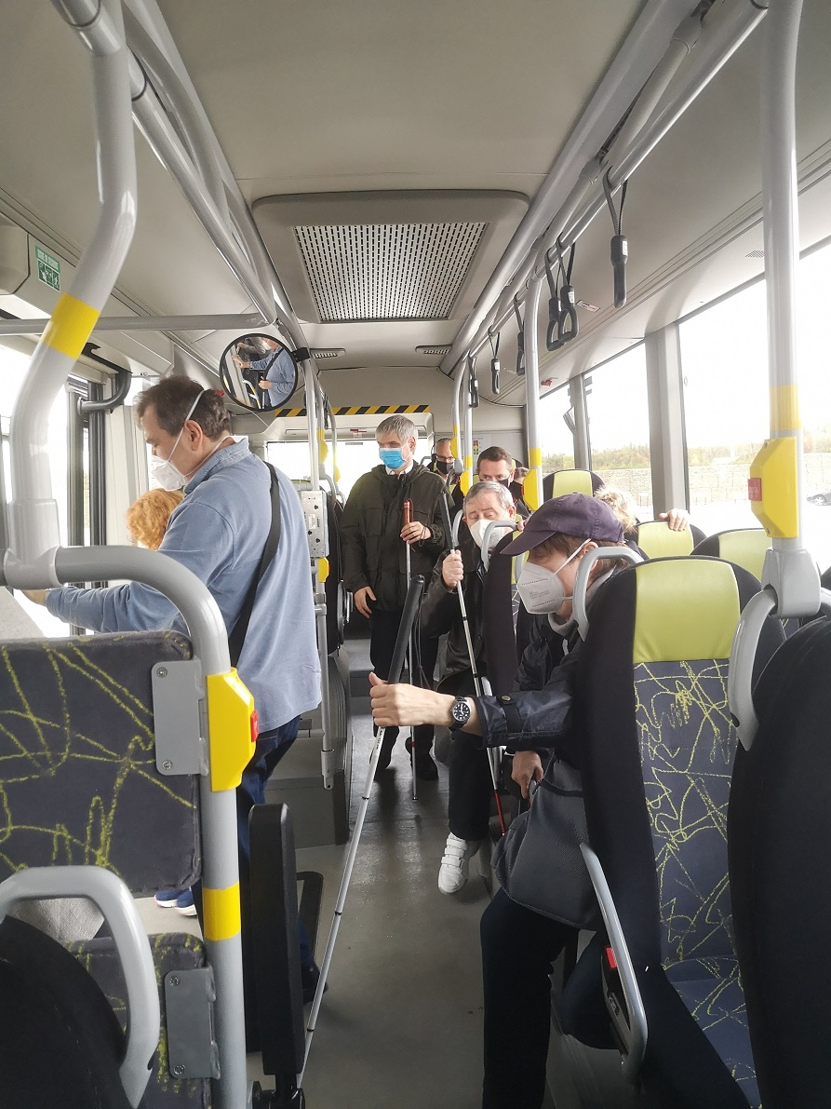

First and most important for the participants was the possibility to get into contact with an operator outside the bus, located in some central or mobile safety unit, who could deliver assistance if needed. Above that, social control by video and speech and visual contact with a natural person outside the bus was regarded as essential in case of emergency and to prevent vandalism and violence. The participants also discussed, that it should be possible to use a future autonomous bus by a smartphone app or beacon, which is standardized at least nationally, but preferably all over Europe. Otherwise one would have to download and learn several different systems, which would make mistakes and stress more likely. In addition also for blind and partially sighted persons it should be possible to use those systems without an additional technical aid, as far as this is technically possible. Another feature could be the opportunity to ask for human assistance, if you are not able to use the system because of an impairment.

Also discussed were the design for all and the two senses principle as well as the necessity of braille instruction at buttons. And – of course – it was emphasized that there may not be any touch buttons in public transport at all but only press buttons to prevent false functions.

All the results will be documented and published in the PAsCAL project report as well as several scientific articles starting at the beginning of 2022 with the publication of the results of a survey on connected and autonomous cars, in which 802 blind and partially sighted persons from 8 European countries participated.

By **Erwin Denninghaus**

## A positive cooperation from Montenegro

The Union of the Blind of Montenegro, UBM and the Association of Blind of Canton Sarajevo, ABCS signed a Cooperation Agreement on Thursday, September 2, 2021.

The representatives of the ABCS were on a study visit to the UBM from July 14 to July 17, 2021. As a part of the study visit, the employees of the UBM presented the way of working and the development of activities and measures that contribute to a better standard of living for the visually impaired people. They introduced the representatives of the ABCS with the work of the Braille printing house, internet radio Phoenix. A special focus and emphasis during the visit was placed on the area of independent living: labeling the name and declaration of the product in Braille and the right to assistive aids. During the visit there were exchanges of experiences in the field of functioning of the Union of the Blind, local organizations, cooperation with government institutions, as well as participation in advocating for the rights of visually impaired people.

The visit resulted in the intensification of international cooperation and joint activities through the signing of the Cooperation Agreement.

The Parties to the Agreement will openly, continuously and in the form of a partnership, cooperate and direct mutual relations and activities in order to achieve common goals, which are related to the commitment to improve the rights and status of blind and partially sighted persons, especially in the field of independent living, rehabilitation and psychosocial support, providing the highest quality professional support and information in accordance with the values of the Parties to the agreement, namely: legality, user orientation, professional competence, responsibility, quality and innovation.

By **Katarina Bigovic**, Union of the Blind of Montenegro

## BrailleTech fair in Belgium

From 14 to 20 October, Brailleliga/Ligue Braille organizes its yearly BrailleTech fair. NEW : we will organize both a ‘Live BrailleTech’ and a ‘Digital BrailleTech’.

Join the exhibition in our head office and discover a wide range of technical aids that make life easier for visually impaired people. This includes simple items that are used on a daily basis but also more complex devices, which require special training. 7 Belgian suppliers will be present at BrailleTech, making it a unique opportunity to try out and compare existing products and innovations. We will also offer a digital BrailleTech. Attendees will be able to learn more about different kinds of technical aids during podcasts, videoconferences and webinars. [The complete schedule (in Dutch and French) is available](https://www.braille.be/nl/over-ons/acties-en-campagnes/brailletech-2021).

Visitors need to subscribe in advance, please visit [www.braille.be](http://www.braille.be) and register. Pay BrailleTech a (virtual) visit and discover much more!

## Whoever thought of tactile surfaces?

Have you ever stopped to wonder who invented the tactile surfaces that are now almost universal at pedestrian crossings?

Well, almost 40 years ago the idea came to Jill Allen King, then a young blind woman living in Westcliff on Sea. Learning to navigate around her neighbourhood after losing her sight, Jill found a patch of “knobbly” pavement in a street near her home very helpful in alerting her to her location.

She was particularly concerned about the risk to herself and others with vision loss at road crossings where the kerb had been dropped flush with the road surface to help wheelchair users to cross. The lack of definition between the pavement and the road was putting blind people at risk.

Jill approached the newly formed Disability Unit in the Department for Transport and invited them to visit her at home to see the surface, which in itself was simply an uneven patch left by a maintenance crew.

From that chance discovery came a research project, led by Cranfield University for the Department for Transport, which led to the very first tactile “blister” surface for pedestrian crossings being installed in Parliament Square in 1983. After further extensive user trials, it became a standard recommended by the Department for Transport to highway authorities across the country.

Refinements such as the use of colour to help those with residual vision pick it out from the surrounding streetscape and the variation of the T or L shape to lead the pedestrian either to the centre of the crossing or to the push button box were also included in the guidance on what has now become a universally recognised feature of our towns and cities.

Further research followed to develop the concept of using tactile surfaces as guidance and warning.

The key to that research was to discover how many different surfaces blind and partially sighted people could reliably detect underfoot, distinguish between and remember over time. The trials involved many people with vision loss and also those with other disabilities to gauge whether surfaces were too aggressive for those with painful conditions such as arthritis.

The blister surface, now so familiar at road crossings, has been criticised as uncomfortable underfoot. The reason why the blisters have to be quite prominent is because people who have lost their sight through diabetes also lose sensitivity in their feet.

From that early research a small number of surfaces were chosen in addition to the one for use at pedestrian crossings. These included one for use at the top of flights of stairs in public places and one to warn of platform edges at railway stations.

From Ann Frye O.B.E

## Royal Dutch Visio is pleased to invite you to a free webinar on Sports



**Sports  
*on October 20 from 2.30 p.m. to 4.00 p.m. (Central European time)***

A series of portraits and instruction videos about playing sports with a visual disability, made in the Netherlands and provided with English subtitles and voice-over, will be presented online.

Playing sports improves the physical and mental condition of people. In addition, sports also means: coming into contact with other people, sharing a passion, exploring your limits, participating and above all having fun.

The objective of the developed products is twofold; on the one hand to give insight into the possibilities of people with a visual disability to people involved in sports, so that they can apply these in their daily practice. On the other hand, to inspire people with visual impairment to also participate in sports.

The portraits focus on young persons with a visual disability and are aimed at all people with a visual disability and those around them. They are mainly intended to inspire and motivate visually impaired people themselves.

The instructional videos discuss adaptations that can be made for different types of sports activities, distinguishing between advice for blind and visually impaired athletes. They are mainly aimed at sports teachers, coaches and trainers and students of sports courses.

Ruud Dominicus and some young people with a visual disability from the portraits, will explain more about this product, the idea behind it, where to find it and how to use it. Ruud is a sports teacher at Visio education, and has also given training in Uganda.

You can sign up for the webinar by sending an email to [international@visio.org](mailto:international@visio.org)

We would like to ask you to forward the invitation to people in your network who have an affinity with Sports.

## EDF webinar - Disability-inclusive employment in a new digital, COVID-changed landscape

During the COVID-19 pandemic, there has been a surge in online/digital inclusive employment initiatives and opportunities for people with disabilities, including online job fairs, working from home, and online training courses.

In this webinar, we will hear about new [Innovation to Inclusion (i2i)](https://www.edf-feph.org/projects/innovation-to-inclusion-i2i/) (External link) research on how assistive technology is bridging the employment gap for people with disabilities in Bangladesh and Kenya.

We will also get perspectives from jobseekers/employees with disabilities, representatives of Organisations of Persons with Disabilities, and employers on the benefits and challenges of disability-inclusive employment’s shift into digital spaces.

Speakers will be announced soon.

Time: 11:00-12:15AM Central European Time, 10:00-11:15AM UK,Ireland

Accessibility: International Sign Interpretation and captioning will be available during the event.

[Registration and further information](https://us06web.zoom.us/webinar/register/WN_llckU491Reu3TfQD0VIwkA) on the EDF website.

## Studying in the UK as VI student

The Royal National College for the Blind has been granted a probationary sponsorship licence from the Home Office.

That means they can welcome international students aged between 16 and 25 to their campus in Hereford, UK while offering sponsorship and support for student visas.

For further details of their international student provision please visit <https://www.rnc.ac.uk/internationalstudents>

ENDS.

**European Blind Union**

6 rue Gager Gabillot, 75015 Paris, France

+33 1 88 61 06 60 | [ebu@euroblind.org](mailto:ebu@euroblind.org) | [www.euroblind.org](http://www.euroblind.org)