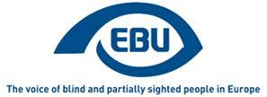

EBU Members' Newsletter 2022

Number ten, November.

Our campaigns

Accessibility
We continue to monitor Creative Europe/MEDIA calls as they come, and namely the most recent 5 calls, published on 20 October. We observed no positive development compared to our paper of early July, in which we deplored that the programme appeared to be only giving lip-service to promoting the inclusion of persons with disabilities through funding to the film industry. We are far from any concrete incitement to provide audio description and audio subtitling.

Equality
On 9 November, we participated in the meeting of the EU Disability Platform’s subgroup on the Disability Employment Package. The Commission invites disabled people’s organisations to indicate if and how they are willing to engage with public employment services, against the background of the Toolkit on strengthening PES to improve the labour market outcomes of persons with disabilities. We had circulated this Toolkit to our members in the EU, for their information.
On 16 November, in the context of the European Week on the Employment of Persons with Disabilities, we communicated on social media about our involvement in the Disability Employment Package. We will need to think about how we can best accompany the Package in 2023 and onwards. Possibly through recommendations to employers on reasonable accommodation for visually impaired workers?

Mobility
A “call for evidence” (new name for what was previously called “roadmap”) on the future EU-wide Disability Card was published on 24 November. We will respond to it. A proper public consultation is expected in early 2023. A meeting of the dedicated subgroup of the EU Disability Platform is expected in the meantime, by the end of this year.
On 30 November, we followed (online) the Annual Workshop on the rights of persons with disabilities, organised by the European Parliament’s Policy Department for Citizens' Rights and Constitutional Affairs for the Committee on Petitions. This year’s workshop was on “Disability Assessment, Mutual Recognition and the EU Disability Card”. More news about this in the next edition of the Newsletter.
On 4 November, together with our Czech member organisation SONS, we attended the NAPCORE Mobility Data Days 2022, more precisely the session on Accessibility of Mobility Data. We made the case the needs of visually impaired people and reminded the participants – including representatives of Member States, of the obligations under Web Accessibility Directive and the European Accessibility Act.

Miscellaneous
On 7 November, we participated in a joint AGE-Platform and EDF meeting “Better protection for EU passengers and their rights”. The aim was to gather input for the European Commission’s public consultation on passenger rights (air, waterborne, rail and bus) through which the Commission seeks to evaluate the EU legislation. Our input particularly focused on the gaps in legislation for intermodal transport. EBU will also directly respond to the consultation (deadline 7 December).
On 24-25 November, EBU attended the European Day of Persons with Disabilities 2022 conference, in Brussels. The focus this year was on the rights of children and young people with disabilities, as well as on violence, in all its forms, against persons with disabilities. The conference discussed how global instruments such as the Convention on the Rights of Persons with Disabilities (CRPD) can help to achieve progress for all people with disabilities across the globe. One of the major announcements made during the conference by the European Commission was about the European disability card, an instrument for which the EC hopes to develop a solid proposal in the year to come. EBU will make inputs in the development of that card, as it has the potential to become a really useful tool in the daily life of people with disabilities in the EU.
As each year, we also communicated around the Access City Award 2023, to contribute to its visibility. This year’s edition rewarded good practices of the following cities, by order of ranking: Skellefteå (Sweden), Córdoba (Spain), and Ljubljana (Slovenia). The following cities also received mentions: Hamburg (Germany) on built environment, Grenoble (France) on transport, and Mérida (Spain) on information and communication technology. For further information, see here.

The Netherlands – Oogvereniging Migrants Day
The Eye Association organized this year's Migrant Day on Saturday 12th of November in the Hague. The topic of the meeting was "Work". There were 75 persons in total. This year, Ukrainian migrants joined, there were 7 of them. Migrants with eye diseases are already better-known about thanks to the Eye Association. The Eye Association's Migrant Support Center has more and more recognition and trust.
The biggest problem is that municipalities usually do not know how to help migrants with eye diseases. Without knowledge of the language it is very difficult to find a job, and then the next reason for refusing to offer work is the presence of vision problems. Migrants are sent to the municipalities, which should help, and they, in turn, can't offer anything, and it turns into a vicious circle. Municipalities should offer more customized solutions and work better with Bartiméus, Visio and Oogvereniging. All these organizations were present at the Migrant's Day.
Migrants could discuss with each other what they faced and share their experiences with each other. There were many emotions and also some disappointments. There were many confessions. Many migrants, especially who were educated and had worked in their own country, want to work in the Netherlands, participate and be useful in society and for society. Many Ukrainian migrants are people with a higher education who are actively looking for work. One Ukrainian migrant said: “I found an unskilled job only after I hid that I had problems with my eyes.”
The director of the Eye Association was there all day. Everyone could ask questions and discuss their problems.
The Eye Association, and in particular, the Migrant Support Centre, have a good understanding of the most common problems faced by migrants with eye diseases. We are going to inform the municipalities and lobby the House of Representatives to bring more attention to this issue. Many people find ways to learn Dutch, look for work, try to participate as much as possible and want to live a normal life in the Netherlands.
www.oogvereniging.nl

Parvis project

Video on the right to inclusive education
Watch the latest awareness-raising video on the right to inclusive education, according to UNCRPD article 24. The translated versions are also available in German, Dutch, French, Lithuanian, Montenegrin, Portuguese, Spanish and Swedish.

E-workshop on the right to inclusive education
An e-workshop on the right to education (UNCRPD article 24) open to all EBU members is organised on December 6th. In this e-workshop, we will discuss the realisation of this right in different European countries, including obstacles, solutions and best-practices. For more information and to register, contact cecilia.ekstrand@srf.nu.

Scottish school students will get a chance to find out what it's like voting when you're blind
Pupils at Uddingston Grammar School in South Lanarkshire got a chance to find out what it's like trying to vote if you're blind or partially sighted.
The school is home to a pioneering Vision Support Team to assist pupils with various degrees of sight loss integrate into mainstream education alongside their sighted peers in the classroom. Established in 1982, the team of specialist teachers offer individualised support to pupils from across Lanarkshire, and further afield.
On Wednesday November 16th third-year Modern Studies pupils cast their vote in a mocked-up polling booth within the school wearing special spectacles that simulated different sight loss conditions.
They used a tactile voting device, a thin transparent plastic template that fits over the ballot paper, guiding you to the box to tick for your preferred candidate.
A Tactile Voting Device in use
The event was organised by Haggeye, the youth forum of national sight loss charity RNIB Scotland.
Kerry Burke (18) from East Kilbride is one of its members. Kerry has the sight condition albinism, with nystagmus and photophobia. Now a sociology student, she was herself a pupil at Uddingston Grammar. Kerry also knows about standing for election; last year she was voted a Member of the Scottish Youth Parliament.
"The Vision Support Team at Uddingston Grammar helped me when I was a pupil in countless ways," she said. "It consistently encouraged me to gain and strengthen my independence, whilst also enabling me to find what works best for my level of vision.
"So it's great they hosted this accessible voting event as it gives Modern Studies pupils a chance to connect the unit within their school to a subject related to their course, the right to vote.
"It’s extremely important to grasp how difficult it can be for some people to cast their vote. And yet voting is vitally important to make sure your voice and opinions are heard and has a real-life effect on the future. So pupils at Uddingston Grammar will hopefully appreciate this message on the day and be more motivated to register to vote themselves when old enough."
Principle teacher Alison Morris said: "Our pupils care deeply about such things, and they have a strong sense of what is fair, what is right, and the value of each other in our school community. We are delighted to have Haggeye and RNIB Scotland working with us on this.
"Our pupils know about the importance of the democratic process, the value of their vote, and their right to vote from age 16 in Scotland. They are keen for other young people to know this too, and for it to occur in a way that includes everyone.
"The work of the Vision Support Team at Uddingston Grammar School has been important in this project, as has our Social Subjects Faculty. Self-advocacy is incredibly important for young people with sight loss, and we actively encourage pupils to have a strong and well-listened to voice, within the ethos of inclusion."
RNIB Scotland, Ian Brown
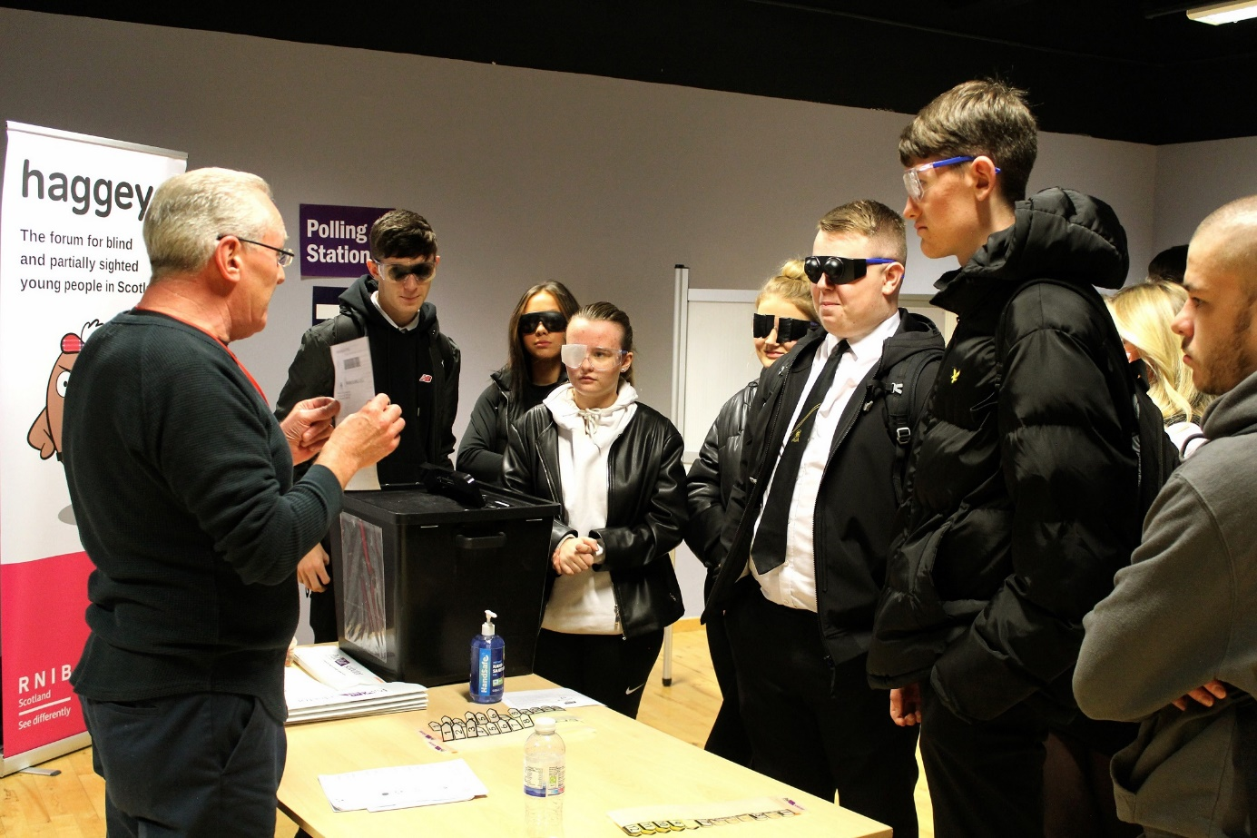
Modern Studies pupils wearing simulation specs

EDF - Companies in the EU to be held more accountable for disability inclusion
The European Parliament approved the final text of the new Corporate Sustainability Reporting Directive (CSRD) on the 10 November.
This new Directive spells out how businesses must report their non-financial activities. During the negotiations, we strongly advocated that companies must report on how they include persons with disabilities and ensure disability issues are considered in their activities.
While the Directive does not directly make companies change the way they approach inclusion, their need to report regularly on actions regarding this domain will force them to reflect and have the power to expose those that are not doing enough.
The adoption of this Directive is just a first step. Now that it exists, a list of reporting standards and questions will be drawn up. This will be done with the support of the European Financial Reporting Advisory Group (EFRAG).

What does the Directive say on disability?
There are clarifications in the Directive about how the reporting standards on disability, inclusion and accessibility should be formed. For example, the Directive states early on that “[t]he reporting standards should also specify the information that undertakings should disclose with regard to the human rights, fundamental freedoms, democratic principles and standards established in the International Bill of Human Rights and other core UN human rights conventions, including the UN Convention on the Rights of Persons with Disabilities […]”
The Directive is also more rigid and specific on how exactly reporting on inclusion should be done. With regards to accessibility for persons with disabilities, for example, it explains that “reporting standards that address employment and inclusion of people with disabilities should specify, amongst other things, information to be reported about accessibility measures taken by the undertaking.”
The reporting standards must also require companies to disclose evidence of “equal treatment and opportunities for all, including gender equality and equal pay for work of equal value, training and skills development, the employment and inclusion of people with disabilities, measures against violence and harassment in the workplace, and diversity”.
This is complemented by requirements for companies to provide “‘a description of the diversity policy applied in relation to the undertaking’s administrative, management and supervisory bodies with regard to gender and other aspects such as, age, educational and professional backgrounds or disabilities”.
These reporting requirements should give a better indication of which employers in the open labour market are serious about the inclusion of persons with disabilities in their undertakings. They also have the potential to put the spotlight on companies not doing enough and to push them to improve their approach.
Contact ; Haydn Hammersley, Social Policy Coordinator

A new book by an EBU Board Member

The book presents society’s attitudes toward the blind
Mehmet Emin Demirci is a blind author, who publishes books and articles about blindness.
Almost 20 years went by since his idea of writing this book about the attitudes of people towards the blind. Thanks to his sighted team which included the English editors, Bogazici University Press and Perpetuity Publications, his book was able to reach the target readership worldwide. “Unfortunately, the most difficult problem blind people face today is still the attitudes of the people towards the blind” said Mehmet Emin Demirci, author of The Blind in History and Society: Wisdom vs. Despair.
His new book examines all aspects of the relationship between the blind and the rest of society within the framework of the attitudes that represent a most productive area of social psychology. The reader will learn that historic figures did not consider their blindness a hindrance to their achievements, be they famous literary personalities or Nobel Prize Laureate. The lives of outstanding blind persons such as Democritus, al-Maarri, Dühring, Rodrigo, Dalén, Borges, Ostrovsky and even Ray Charles, are examined while placing blindness and the blind at the center of social relationships, utilizing rich historical presentations and comprehensive analysis. His book will be of interest to many professionals, educators, historians, social scientists and general readers.

About Mehmet Emin Demirci
Mehmet Emin Demirci was born in Kurucuova, a small rural village in central Turkey, in the province of Konya. Born with childhood glaucoma, his vision deteriorated during his early years in primary school. After mastering English, he competed to enter one of Turkey’s top schools, Bosphorus University and went on to receive an undergraduate degree in Sociology, followed by an MA in Adult Education at the same school. Over the years, he has worked with national and international organizations of and for the blind and has travelled extensively, attending many conferences dealing with blind issues. His book The Blind in History and Society: Wisdom vs. Despair is available. You can also contact him by email.
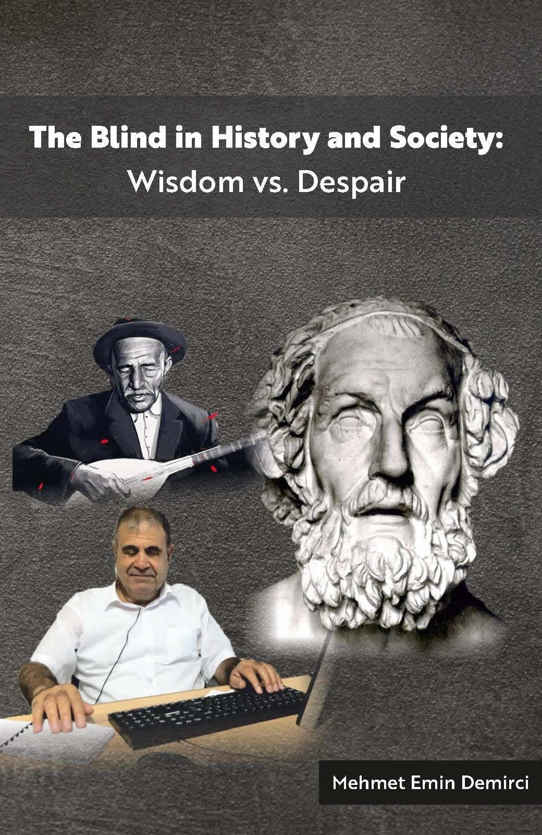
The cover of the book by Emin Demirci
ENDS.
European Blind Union
6 rue Gager Gabillot, 75015 Paris, France
+33 1 88 61 06 60 | ebu@euroblind.org | www.euroblind.org

