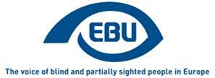

EBU Members' Newsletter

Number ten, November 2020.

OUR CAMPAIGNS

Creative Europe/MEDIA
On 18 and 19 November, in the context of the interinstitutional negotiations on the regulation for the Creative Europe programme for 2021-2027, we sent a joint letter with EDF to key contacts at the European Parliament, including the Disability Intergroup, the Council and the Commission. In the letter, we expressed support for a general clause of inclusion in the article defining the objectives of the programme, on condition that (a) it be strongly worded – we recommended wording – and (b) that it be not to the detriment of some designated and important amendments proposed by the European Parliament that specifically concern persons with disabilities.
This opportunity was used to circulate again and more widely our position paper about EU MEDIA funding to the film industry.

Marrakesh Treaty
Some information about the status of non-EU countries of the European Economic Area: while Switzerland (the only European Free Trade Area country outside the EEA) has signed and ratified the Treaty early on, Iceland, Liechtenstein and Norway are not yet in. There is no automatic spill over effect of EU law to the non-EU countries of the EEA. The EU’s Marrakesh Treaty Directive (2017/1564) therefore needs to be incorporated into the EEA agreement, and we are now past the usual 6 month delay for that process. We invited our members in Iceland and Norway to enquire with their national government and express a sense of urgency.
Together with the Western Balkans country plus Armenia, Turkey and Ukraine, the three non-EU EEA countries count among the few European countries that have not yet joined the Treaty.
Looking beyond Europe, good news: with Turkmenistan joining, the Treaty reached 100 countries covered worldwide.

Accessible lifts
After expressing dismay that we had not been invited by CEN/TC 10/WG 7, the EU standardisation body’s working group that is revising the accessible lifts standard, at their follow-up meeting of 7 October, we were invited to participate in their subsequent meeting (25 November). Unfortunately that invitation came too late to ensure our useful participation, and the object was to enter into very technical details of the already agreed compromise on the issue of the colour contrast of operating buttons. We marked our interest to be involved rather in the meeting where the next important issue will be discussed, i.e. the use of braille.

Equality in employment
We intervened in a video produced by MEP Katrin Langensiepen’s team, to promote the recommendations contained in her report to the European Parliament on the implementation of the Equality in Employment Directive. The draft own-initiative resolution of the European Parliament is expected to be voted on at its EMPL committee in January 2021.
In the meantime, on 19 November, we participated as programmed speakers in a webinar gathering representatives of the three main EU bodies, on the topic: the situation of persons with disabilities in the labour market and what concrete initiatives could be taken at an EU and national level, in connexion with the upcoming post-2020 EU Disability Strategy.

EU Disability Strategy
The European Commission has recently published its evaluation of the currently ending European Disability Strategy. In the conclusions we are happy to read: “a comprehensive framework of statistic indicators covering all the key priority areas of the Strategy is needed to identify gaps, to measure progress in the situation of persons with disabilities in the EU and to set clear targets for the Strategy. In general terms, EU-wide disaggregated data on persons with disabilities would be an important tool for monitoring and evaluating European policies aimed at improving the situation of persons with disabilities.”
On 4 November, we participated in the 3rd of a series of consultation meetings on the European Disability Rights Strategy post-2020.
In this round of consultations, started in October, we particularly focused on the following concerns: recognition of the disability status across the EU (EU Disability Card); access to culture (EU funding to film industry and AD and AST conditionality); gaps of the EAA (public urban transport, built environment, household appliances); accessible voting (EP elections 2024); clarifying the obligation of reasonable accommodation for equality in employment; training in digital skills; EU disaggregated statistics per disability, to monitor the employment gap; the consideration of PWDs in crises such as the COVID-19 pandemic. Since justice, health and education were also on the agenda, we also made good use of the EBU Statements on the relevant articles of the UNCRPD.
On 11 November there was a round-up meeting in the presence of Commissioner Dalli in which she summarised the main learning of this round of consultations. Our impression is that we and other DPOs were well and widely heard on the orientations of the future EU disability policy, but less so on the necessary institutional arrangements to mainstream disability in EU policy.
The future strategy is expected to be adopted in the first quarter of 2021.

Other consultations by the European Commission
We participated in the following consultation meetings:
- Workshop on evaluation of Regulation 1107/2066 - air passenger rights (10 November)
- Strategic Dialogue online meeting "Consultation on the Action Plan for social economy" (10 November)
- Strategic Dialogue meeting "The Child Guarantee" (26 November)
We responded to the following online consultations:
- on the Roadmap for the European Disability Strategy 2021-2030.
- on the review of the EU set of indicators to monitor the implementation of the UN Sustainable Development Goals.
And we are currently preparing our response to a consultation on the new EU strategy on rights of the child (2021-2024).

Events
- On 20 November, EBU held (online this year due to the COVID-19 context) its annual meeting of the Commission for Liaising with the EU, where stock was taken of main activities since the last meeting, and priorities for future work were identified.
- We are preparing our participation in the European Day of Persons with Disabilities 2020 conference (1-2 December)

Job opportunities - EBU is looking for a PARVIS Project Coordinator and a Communications Officer!
In the framework of its new awareness-raising European project PARVIS, due to start in early 2021, the European Blind Union (EBU) is looking for two collaborators: a PARVIS Project Coordinator and a Communications Officer.
APPLICATION DEADLINE: 6 December 2020.
ANTICIPATED START DATE: 5 January 2021.
JOB TITLES:
- PARVIS Project Coordinator
- Communications Officer
TYPE OF CONTRACT: Part-time (17,5h per week) and fixed term (2 years), French-law.
LOCATION: Paris, France; other arrangements like home-based work are open for discussion.
MOBILITY: up to 2 trips per year to the Netherlands and Sweden.
REPORTING: The PARVIS Project Coordinator and Communications Officer report directly to the EBU Project Officer.
SALARY: see job descriptions.
SUMMARY OF POSITIONS:
- See job description for PARVIS Project Coordinator
- See job description for Communications Officer
Willing to join our organization and help change the lives of millions of blind and partially sighted persons? Send your CV and cover letter in English to ebusecretariat@euroblind.org by 6 December 2020. Applications by persons with disabilities are encouraged. Applicants must have a valid work permit for working in France.

Collaboration between Croatia and Montenegro
The Croatian Blind Union and the Union of the Blind of Montenegro signed a Cooperation Agreement on November 4, 2020. The agreement is part of the activities within EBU Mentoring in 2020. During a two-day visit in September 2020, representatives of the Union of the Blind of Montenegro exchanged views and experiences on topics of importance to the visually impaired with representatives of the Croatian Blind Union in Premantura, Croatia.
During the first day of a visit it discussed the specifics of an educational rehabilitator’s work, the approach to visually impaired persons, accessible environment, standards of accessibility, independent living and orientation. The second part of the day was reserved for echolocation, through the theory, and through various games and practical part where the concept of obtaining information through sound reflection was explained.
During the second day we talked about sighted guide services, establishing such services, implementation challenges, experiences and benefits.
The objective of the Agreement is to intensify international cooperation, joint initiatives and actions to improve the rights and status of blind and partially sighted people, especially in the field of independent living, rehabilitation and psychosocial support, providing visually impaired people with the highest quality professional support and information on relevant values: legal issues, customer focus, professional competence, responsibility, quality and innovation.
We encourage members of the European Blind Union to cooperate more with each other.
Katarina Bigovic, UBM
Petar Glavas, CBU

The Results of the 2020 Onkyo World Braille Essay Contest
The Onkyo World Braille Essay Contest is a worldwide initiative planned and sponsored by Onkyo Corporation and The Braille Mainichi, two Japanese firms actively engaged in the promotion of braille. Its European strand is run by the European Blind Union.
The 2020 edition of the essay contest received a total of 45 participants from 16 countries
The authors of the winning essays receive prizes made available by Onkyo and Braille Mainichi.
This year's First Prize winner is from Spain, María Jesús Cañamares Muñoz, who wrote a topical essay entitled 'Braille and Lockdown'
The full list of prize winners is as follows:
Otsuki First Prize:
Braille and Lockdown by María Jesús Cañamares Muñoz (Spain)
Excellent Works Prize:
Senior Category: Viorel Serban, (Romania), The Moment That Changes The Course of Life
Junior Category: Amir Gumerov (Russia), Braille and Music
Fine Works Prize:
Senior Category:
- Anne Kochanek, (Germany), Greetings from Dots
- Tone Mathiesen, (Norway), Braille in the Past and Present
Junior Category:
- Andreas Rudisuli, (Switzerland), Is Braille Still Needed Today?
- Seb Sloot, (Netherlands), Braille song
The First Prize-winning essay is produced in full below, and you can download and read the texts of all the prize-winning essays on our dedicated Onkyo page.
EBU congratulates all the winners, and thanks all participants and their member countries for their involvement. We hope many of you will feel inspired to participate in the next edition of the Onkyo World Braille Essay Contest!
Happy reading!

Braille and Lockdown
María Jesús CAÑAMARES MUÑOZ (Spain)
We have been locked up at home for too long now as a result of of a pandemic that’s devastating the whole world. We can’t do the shopping or go to social gatherings or events where we can interact with others. A few months ago, we didn’t have time to watch television, phone a relative to ask about their health or play with the kids…now, we have more time than we need.
Having said this, I find the methods we use to communicate with others at a distance cold and boring. The synthetic voices in my computer annoy me. The press and TV bring us more than enough information and shocking figures about the number of deaths and infection rates. I can’t stand the WhatsApp messages with videos and photos I can’t see but have no text and, quite often, the jokes are in bad taste. But how can I fill these days of forced loneliness? My mind is sombre.
Then suddenly a marvellous genius by the name of Louis Braille, inventor of the tactile reading and writing system of the same name, based on just six dots, a system that has saved so many blind people from illiteracy over the past two hundred years, brings me a ray of light.
“Where are those books you bought as part of the “A book a month” collection? The ones you stopped reading when you discovered new technologies. And where are those folders with your most intimate memories of when you were a child and a teenager?”
Fantastic! Thanks to Louis’ suggestions I have something to keep me entertained for several weeks. I switched off the TV and the computer right away, went up into the attic and, in a matter of minutes, I was in my room with those boxes full of books, folders and memories. I put on a CD of relaxing music and let it play.
Oh, a letter from Julia, the teacher in the village. Alphabet in hand, she taught herself braille and sent this letter to the school where I was studying. It caused me more than a few headaches as I tried to read it in every direction - vertically, horizontally and perpendicularly – but it was impossible to decipher. It was written using a slate and stylus and after a few attempts I reached the conclusion Julia had written it from left to right, just as sighted people write using a pen. So, I had to read it the other way round, from right to left. It was tough work but with a happy ending because I was able to understand what she had written.
And here, in this other compartment, are my never-ending maths exercises, with the equations and calculations Tomas, my teacher, set me, the ones I always got wrong! Now I think about what it would be like to do these exercises on a computer. I’m sure it would be impossible for me because I’m incapable of working with Excel rows, cells and columns.
I go on looking through the box with my fingers and a laugh from my throat echoes around the room. Pepe’s assignment! I asked him to do it when I had the bright idea of working as a braille monitor at the ONCE branch office in Cuenca. He had to write five words related to braille and, when he had finished, he handed it to me: stylus, paper, brailler, slate and…
“There’s a word missing”, I said with a smile.
He read the words several times and insisted everything was correct, but I insisted it wasn’t so he gave me the piece of paper again to check it.
“There’s one missing. It says “cot” here.
Pepe’s embarrassment and everyone’s laughs make for a great story. Without meaning to, he had given us one of the funniest moments of the course, and so I decided to keep that amusing memento.
I go on reading and, at the same time, listening to the music, which comforts me more and more. Then I realise that if, instead of reading braille, I had been listening to a voice synthesiser, I wouldn’t be able to listen to both at the same time, because the sound would come from the same loudspeaker. Braille and technology are not at odds; they go together, complement each other and can help a blind person learn more and better and be more independent. But there are times, like this one I’m telling you about, when we need to choose one system or another.
What’s this? Ah, it’s my little book of mysteries and litany of the holy rosary! That’s what I called this manuscript I wrote with the help of my mother’s dictation. I caress it and take the firm decision to pray from it every day, after going out onto my balcony to applaud as hard as I can the health workers who are looking after us and giving their all to save us from the coronavirus.
I lift the cover of my watch and, on the braille dial, I see it is five minutes to eight. That’s when I drop everything and clap my hands enthusiastically for a good long time. I return to my room and, rosary and book in hand, I pray fervently, asking Louis to intercede with our father for all the sick people who are suffering, all the relatives who fear they will pass away, and all the health workers who, at the risk of becoming infected, work tirelessly to cure us.
I finish my prayers and grab something for dinner, then I go to bed with a braille book I’ve read a hundred times but will read a hundred times more. I am completely overcome by a sense of inner peace and tranquillity I have never felt before. And now, more than ever, I understand what braille means to me. Thanks to braille, which will always be there when we most need it, I feel surrounded by friends, teachers, family and characters from the books I read.
And, little by little, I fall asleep. I hope my dreams are sweet.

Norway – fighting for subsidised glasses for children.
The government's reduction in the benefit program for children's glasses created a lot of noise last autumn. This year we have worked hard to bring attention to this issue.
The Norwegian Association of the Blind and the Norwegian Association of Opticians believes that the new rates do not cover the costs of good and functional glasses for the children that need treatment. The result of this can be that the parents' wallet decides whether children get the glasses they need.
Lack of glasses can cause permanent damage to vision and cause reduced educational benefits.
I received correctly tailored glasses in the 2nd grade, and from then on I could fully benefit from my education. Most people who have experienced this during their education understand that glasses must be properly adjusted, and that it is necessary to change glasses as vision develops. This provides a basis for their entire education.
Parents understand this, and most children get the glasses they need. However, it comes at the expense of other things. Other activities may end up being not prioritized, and sometimes grandparents have to step in financially. Children also perceive this and may feel like a burden to the family.
We are working for a solution where children's glasses are fully covered by the state, so that children who need glasses are not left out of play and education, says Terje André Olsen, president of The Norwegian Association of the Blind and Partially Sighted.
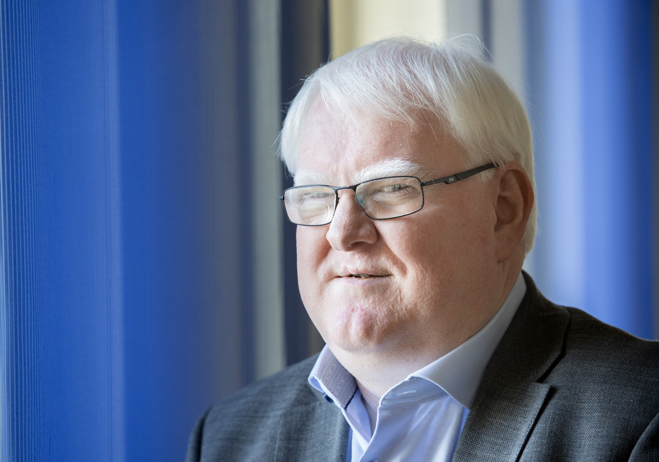
Terje André Olsen

Iceland holds its’ General Assembly online
The general assembly of Blindrafélagið, Icelandic Association of the visually impaired was held digitally in the middle of October. The board had postponed the meeting from May due to the meeting restrictions during the COVID-19 pandemic. The meeting was held as a Zoom meeting and we used the "raise hand" feature for simple voting. All in all, that was a good solution, but blind participants told that they were not always sure if they had voted or not. The technical lead of the meeting counted the votes and helped participants to unmute and mute their microphones if needed. The meeting was also streamed through our WebBox to those who did not want to participate but were interested in following.
We introduced a special election system which allowed us to hold elections of the chairman and the board members in a secure digital way. The Icelandic company, Könnuður, is specialized in digital voting and adjusted the system to work with screen readers and keyboard shortcuts. All who participated managed to vote without difficulties. The identification of the voters was done by using their mobile phone number. For those who could not vote digitally we offered possibility to vote in our office.
In general, we were satisfied with this arrangement. The members living in rural areas of Iceland were pleased to be able to participate at home. This was the first time we introduced the option of voting online and it was received well by all members.
By Marjakaisa Matthíasson.

EDF survey on the implementation of the Web Accessibility Directive
In 2016 the European Union Directive 2016/2102 on the accessibility of the websites and mobile applications of public sector bodies was adopted with the objective to make public sector websites and mobile apps more accessible to persons with disabilities.
According to the Web Accessibility Directive, by 23 September 2020 all public sector websites must comply with the requirements of this European legislation. Help us understand if this is the case and if your country has actually taken full advantage of the Web Accessibility Directive.
This survey is primarily intended for persons with disabilities. EDF will treat your responses confidentially.
Based on the information gathered, EDF will prepare a public report to be presented to the relevant EU institutions and distributed broadly to put pressure on the public sector at national level to make their digital services more inclusive to persons with disabilities which is the end goal of this EU legislation.
If you have any doubt, do not hesitate to contact alejandro.moledo@edf-feph.org
The survey is available in English, French, and Spanish, and you can also select the language from the drop down menu.

The International Blind Football Foundation - a new support scheme for national teams worldwide.
The IBF Foundation Blind Football Neighbouring Countries Challenge Series, supported by Santen grant programme invites national teams worldwide to apply for financial support to hold international friendly matches with neighbouring countries as they reinitiate activities after the global pandemic.
The goals of the IBF Foundation Blind Football Neighbouring Countries Challenge Series, supported by Santen grant programme are:
- to help reactivate blind football globally as we move towards a new reality following the global pandemic caused by COVID-19;
- to assist countries to overcome the financial difficulties they may face in returning to international competition;
- to present a positive image of our sport to the world and demonstrate that blind football, with proper health, hygiene and safety protocols and procedures in place, can offer a safe, virus-free environment for visually impaired athletes.
The IBF Foundation invites countries to pair up with neighbouring countries and submit joint applications for funding to organize and play 2 friendly international matches in one of the two. Applications must be submitted by two organisations from adjacent countries or, where air travel is required, two organisations in countries under five hours flying time from each other.
The games must be played by the national blind football teams of the two countries engaged in the programme. Successful applicants will stream the matches live to showcase the skills of blind footballers in the post COVID-19 era, and the IBF Foundation plans to launch an official website to show the games.
Organizations will be allowed to apply for the grant only once and a strict health and hygiene protocol must be respected during the event to prevent infections.
Grants of up to 10 000 US Dollars are available for projects involving air transportation, while projects involving travel by land are eligible for a grant of up to 5 000 US Dollars.
Countries interested in benefitting from this grant programme must complete and submit the required documents to info@ibf-foundation.football by Saturday January 2nd, 2021 @ 12:00 Tokyo time. Following evaluation by the IBF Foundation grant programme team, successful applicants will receive confirmation by Friday January 15th, 2021 @ 12:00 Tokyo time. All projects must be finalised by November 30th, 2021.
About International Blind Football Foundation (IBF Foundation)
IBF Foundation was established on January 11, 2019, with the vision of "Blind Football Can Eliminate Disability". The foundation's aim is to improve the quality of life of the visually impaired around the world by making blind football a sport widely played internationally and contributing to the organizational strength of national sports organizations. Through blind football, the foundation works to solve the three elements of disability (impairment, activity limitation, and participation restriction) as defined in the International Classification of Functioning, Disability and Health by the World Health Organization (WHO), by taking the following three approaches: (1) intermediate support activities, (2) cooperation with partners, and (3) acting as an independent business.
Please check out all the information:
https://www.ibf-foundation.football/grant-programmes
Contact:
info@ibf-foundation.football
ENDS.
European Blind Union
6 rue Gager Gabillot, 75015 Paris, France
+33 1 88 61 06 60 | ebu@euroblind.org | www.euroblind.org

