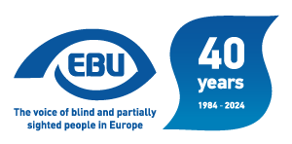

EBU Members' Newsletter 2024

Number five, May.

Our campaigns
Activity at EU level has started to slow down in view of the European elections in June and the end of the current Parliament and Commission.
We were invited by the European Economic and Social Committee to contribute an article for their newsletter on the accessibility of the European elections. We focused our contribution on the issue of accessibility of the elections for voters and candidates.
On the subject of the European Elections, from mid-May until the end of the month, EBU launched its #StandForInclusiveEU campaign in all its social media channels (Facebook, LinkedIn and X). Through this initiative, our organisation aimed at calling candidates and political parties for action in key areas for blind and partially sighted people across the EU such as access to culture and education, accessibility of the built and digital environment, free movement or political participation. This topic was also covered in episode 7 of our EBU in Action podcast .
At the European Commission Strategic Dialogue meeting of 30 April on fair transition towards climate neutrality, we:
- welcomed the EU’s efforts to assure equal access to quality and inclusive education in order to close the disability employment gap;
- recalled that EBU is active in denouncing the disability benefits trap (people losing disability benefits because they engage in paid employment);
- provided examples of best practices that connect the disability agenda to the green transition agenda, namely our work to promote safety feature features for silent cars (electric and hybrid vehicles) with the AVAS system;
- invited the stakeholders to investigate connecting the issue of the developments in urban mobility to accessibility of new transport solutions, like driverless vehicles; and
- pointed out that building renovation is an opportunity to make houses more accessible, a mix of taking stock of what has been accomplished in the past 5 years and looking at the way forward.
On 7 May we attended the EDF-Microsoft Accessibility Summit, see the dedicated article in this newsletter.
On 13 May we participated in the Commission’s Strategic Dialogue meeting on the Future of the Union of Equality. We:
- acknowledged that the Strategy for the rights of persons with disabilities is a driving force of policy and has already made a remarkable impact in the current mandate;
- invited the Commission to try to avoid the conference-type format for the Disability Platform meetings, to try to keep it as interactive as possible;
- welcomes AccessibleEU is a promising initiative to facilitate input to the EU standardisation process, but the Commission should ensure EU-wide disaggregated data collection on disability, necessary for policymaking and drafting new legislation;
- expressed the need to address the gaps of the Accessibility act (with regard to accessible household appliances) or in relation to the European Disability Card (to address the needs of people who move to another country to live and not only travelling); and
- emphasised that EU could do more to use the leverage of the EU funding to promote good practices in accessibility, e.g. via Creative Europe Programme or the funds aimed at fair transition to climate neutrality.
On 23 May we participated in a European Disability Forum webinar on EU legislation of interest to organisations of persons with disabilities, namely the Equality Bodies Directive, the Anti-trafficking Directive, the Digitalisation of Justice Regulation, and the Energy Performance of Buildings Directive.
On 28 May we followed a workshop on the new EDF Enforcement Toolkit and how to enforce EU law, focusing on the following three of the mechanisms: the European Parliament Petitions’ Committee, the European Ombudsman, and Equality Bodies.
30/5 DAISY Consortium meeting in Paris, to present our concerns in relation to the item “Countdown to the European Accessibility Act”. We addressed the following three aspects regarding e-books:
- the 5-year extension of the deadline under Art 32(1) of the EAA for products that are used in the provision of a service: how that affects e-books;
- how the EAA addressing e-books does not undermine the efforts to respond to the need for accessible books in various formats, to meet the various needs of visually impaired people; and
- the issue of legacy e-books (‘backlist’), also on the agenda of the EU Inclusive Publishing Forum meeting of 11 June and which we will attend as well.
We were invited and agreed to speak on the Marrakesh Treaty at the Irish National Disability Association’s Annual Conference in October (more on this to follow).

EU talks to users and producers about improving Braille displays
After worldwide research on the usage of Braille displays with over 900 participants, EBU’s Braille Working Group discussed major important requirements for the improvement of the access to electronic Braille with producers during the Sight City fair held in May in Frankfurt, Germany.
A number of suggestions for improvement were made in the areas of quality and durability, connectivity and driver unification, operating standards as well as manuals and training. Communication between users and producers will go on.
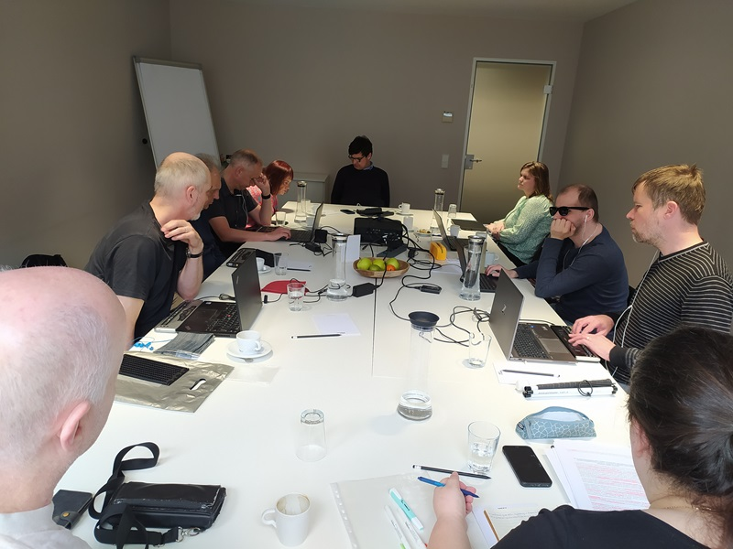
Members of the EBU Braille WG around the table.
From December 2023 to the end of February 2024 the Braille working group of the European Blind Union conducted the survey Braille Display Usage. This survey offers an overview of Braille display usage and Braille display users’ expectations. In this survey responses from 912 respondents from 59 countries were collected. Most of them were Braille users, but responses from educators and braille trainers were also included. The analysis of all responses is available on livingbraille.eu, the portal which represents a Braille resource website of EBU. A conclusive document, Results of the survey “Braille Display Usage”, offers a complete description of the findings and suggests specific areas for improvement in the future.
The results of the survey served as a powerful cornerstone in the discussions with the public and with Braille display manufacturers during the in-person meeting of the EBU Braile Working Group in May 2024 in Frankfurt, Germany.
The SightCity exhibition, with tens of Braille producers exhibiting their products, was a invaluable opportunity for the group members to not only meet and see different Braille tools, but also to bring together the public and Braille display producers in a conference room to openly discuss the survey participants’ opinions. The five areas most frequently mentioned in the survey of Braille display usage were chosen for discussion: namely quality and price of Braille displays, connectability and drivers, functions and operability, bluetooth connectivity and training materials. The public discussions confirmed yet another important item, uniformity in usage of Unicode Braille patterns within the Braille display internal environment.
All these areas were discussed during the meeting with Braille display producers. We were very pleasantly surprised by the high number of companies joining us for discussions. We went through all the areas and laid out main important findings.
The members of the Working group pointed out the concern of the survey participants of the decreasing quality of Braille dots or Braille cells installed in the devices. Producers assured us, however that the quality is thoroughly tested by blind users. The recent reduction in dot quality might be a result of the still on-going search for good and reliable technology with lower costs leading to potentially more affordable braille displays in the future. Nevertheless, we expressed strong advocacy for reliable and long-lasting Braille cells with evenly levelled dot heights. The Braille Working Group will create a checklist of basic functionalities and features of braille displays for users to be able to make an informed decision when buying a new Braille display. Thus producers can compare their displays against this checklist in order to have minimal requirements.
Additionally, it was proposed:
- to create an article on livingbraille.eu about the users’ actions to keep their Braille displays clean and in good shape and to visit the dealers for regular maintenance if possible;
- producers should be more open for feedback, establish a channel for direct feedback from the users, not only through the dealers;
- Create the possibility to exchange one cell instead of a segment or even the whole display;
- encourage all producers to implement Unicode Braille as part of the Braille device itself;
- there should be a temporary hire of braille display offered in the period of user's one is being repaired.
In the area of connectivity issues very positive information from Braille display producers was received. There is a real possibility of quite an elegant solution in the near future. Human Interface Device (HID) standard is widely known as a solution for the devices’ connectivity in all the platforms and devices. HID for Braille displays exists and recent developments suggest its implementation in most used platforms quite soon. Braille users can hope this will solve a lot of problems participants mentioned in their responses.
The guests from producing companies also suggested to pay attention to the updates of their operating system, screen reader and firmware of the Braille displays. Many issues are being solved within these updates so users can avoid repeatedly facing these problems. For example, on connectivity issues, a lot was solved within the last year, therefore producers encourage all users to check for all available updates. EBU Braille Working Group will closely follow the HID implementation and inform about this on livingbraille.eu.
As for the operability of Braille display buttons and functionality and also for training materials Braille Working Group members asked producers to consider making better materials available online, so that users do not need to rely only on written guidelines, but can learn from more interactive materials. They suggested podcasts, video or audio manuals, paying attention to the different language options also for non-English speaking users. Internet and producers offer this kind of material, but the majority of it is in English. Producers cannot rely on the distributors to carry out this mission in their countries.
The EBU Braille Working Group will collect and create more materials about Braille displays, producers, manuals and more on the livingbraille.eu portal. The website will be developed and filled with materials, links to different resources. It was also proposed to use artificial intelligence to make controlling Braille displays and screenreaders easier, e. g. by voice commands.
The discussions with Braille display producers have just been opened and established, The EBU Braille Working Group will continue to further these discussions and meetings in the future to provide more information and play an important role in the shared dialogue between users and Braille display producers.
EBU wants to thank Braille producers for taking part in our efforts and meeting with us. Their positive attitude gives us hope for better communication in the area of digital Braille in the future.
We would also like to encourage all users to visit SightCity exhibitions in the future. It is a wonderful opportunity to literally touch the devices before purchasing. The EBU Braille Working Group expressed a strong belief that a well informed choice of Braille displays will play a key role in the users overall satisfaction with digital Braille usage.

The Braille Working Group of the European Blind Union
The Braille working group was established in 2020 and since then members of this group have been working on various projects to promote Braille and improve its usage in all areas of life for blind People. In 2022 the group presented a video about the importance of braille, which is available on a YouTube channel as well as on the Braille promotion webpage of EBU. In 2023 EBU issued an important position paper on Access to Reading and Using Braille – a matter of the future, which is also a result of the efforts of the Braille working group.
Livingbraille.eu, the portal of EBU, is an achievement of the EBU Braille working group, where Braille information has been collected since May of 2022. Anyone can contribute and add to the Braille knowledge database. Among other information, there is also an important list of the Braille authorities of Europe.
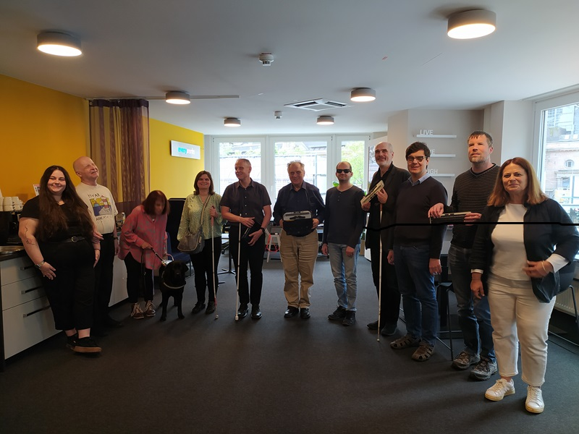
A group picture of members of the Braille WG standing together.

The EU Accessibility Summit 2024: An insight on the current state of inclusion across the Union
Inclusion is a concept that needs to be constantly revised as a whole in order to build a more equal and non-discriminatory society. Conceived as a forum to gather accessibility professionals, disability advocates and policymakers, EDF and Microsoft co-hosted the 4th EU Accessibility Summit on 7th May. Speakers at the event, as well as participants, engaged in a fruitful exchange focused on key areas for people with disabilities across the EU.
Although legislation has been adopted to move towards a more inclusive EU, it still needs to be further developed so it can be effectively implemented. That’s the case of the European Accessibility Act (EAA): although a milestone in the setting of accessibility standards, it still remains too focused on digital products and services, as our organisation has already underlined in the past. Furthermore, as pinpointed by Inmaculada Placencia, a Senior Expert on Disability at the European Commission, the EAA is not fully implemented in certain Member States. In line with this, Alejandro Moledo, Deputy Director at European Disability Forum, emphasised the role of monitoring and enforcement in building a more accessible world, suggesting the creation of agencies to fulfill that purpose.
At the same time, other participants, such as Klaus Miesenberger, Head of the Institute Integriert Studieren at the University of Linz, highlighted the importance of establishing guidelines so products and services can be developed under the principles of inclusive design. In line with this, Klaus welcomed the launch of the Accessible EU Centre (one of the flagship initiatives of the European Commission’s Strategy for the Rights of Persons with Disabilities 2021-2030) as a good discussion point to exchange good practices and as a tool to educate both end-users and professionals working in the disability area.
Raising awareness of the importance of accessibility in the daily lives of people with disabilities also requires that their voice is taken into account at a political level. With the 2024 European elections taking place from 6th to 9th June, Helga Stevens, a former member of the European Parliament, stated that “governments still don’t grasp the idea of having fully accessible elections, as well as the importance of ensuring the representation of diversity in institutions.” In an era where campaigns have quickly moved to the digital world, speakers such as Nellika Valder, Deputy Head of the State Electoral Office of Estonia, or Dave Leichtman, Director of Corporate Civic Responsibility at Microsoft, pointed out some issues in that area, such as the lack of accessibility of political parties’ websites. In a fruitful debate, they all reflected on the importance of considering persons with disabilities’ needs when accessing political information through co-creation processes.
Monitoring inclusion in the labour market and the challenges of Artificial Intelligence
Apart from debates about the accessibility of products and services and the current state of people with disabilities’ right to take part in political life, the 2024 EU Accessibility Summit also hosted an interesting discussion about how inclusion has evolved in workplaces across the EU over the last few years. The discussion revolved around the impact of the Corporate Sustainability Directive as a reporting tool in order to ensure the implementation of article 27 of the UNCRPD. Delphine Leveneur, Chief of Engagement Officer of the Valuable 500, pointed out that people in charge of monitoring processes in this area need to understand what’s actually behind the data in order to make progress.
As part of statistics-collecting tasks, Artificial Intelligence has been seen by some experts as a possible solution to the problem. However, Carla Bonino, Sustainability Chief at Fundacion ONCE, remarked that data analysis is a much more complex process. In the same line, EDF Executive Member, Thorkild Olesen, stated that while AI applications might have the potential to improve the lives of people with disabilities, its design must consider their needs. To achieve that goal, he also underlined the need to have disability champions who lead awareness-raising campaigns in this field.

Information and request from EGDF
We are forwarding the following request from the European Guide Dog Federation, feel free to reply.
European Civil Aviation Conference (ECAC) response to flying with assistance dogs.
ECAC set the guidelines that advise all European Airlines on many policies, including the carriage of guide and assistance dogs.
We have been corresponding with them for some time to address the confusion surrounding their recommendations on travelling with an assistance dog; joining forces with our colleagues in ADEu, ADI and IGDF.
We know that ECAC have been looking at this problem and are pleased that they have asked for our help in gathering evidence.
You can read the full response from ECAC here - ECAC Letter.
If you could please let us have any examples of the problems you, or your guide or assistance dog partnerships, have encountered when travelling or attempting to travel by air, in the last few years, that would really help in providing proof.
Either send me an email with the details - jane@egdfed.org, or complete the form from the link below, please complete one form for each journey.
Report Air Travel Problems

DBSV Cultural heritage survey
The German Federation of the Blind and Partially-Sighted (DBSV) is partner of the SHIFT project funded by the European Union's Horizon Europe Research and Innovation Program. We are working to make cultural heritage more accessible, inclusive, and appealing for all with an added focus on accessibility. Please help us by taking a few minutes to answer a few questions on this page.

EDF's Enforcement Toolkit
The aim of this toolkit is to provide persons with disabilities and their representative organisations with an overview of the remedy mechanisms that they can use when they experience or identify a breach of their rights as contained in EU Law and clarify which one is the most appropriate for each circumstance. Since enforcement is a combined effort of both European and National bodies, this toolkit makes a distinction between these two administrative and judicial levels.
More information and the toolkit on the EDF webpage.
ENDS.
European Blind Union
6 rue Gager Gabillot, 75015 Paris, France
+33 1 88 61 06 60 | ebu@euroblind.org | www.euroblind.org

