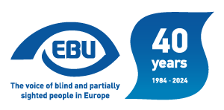

# EBU Members' Newsletter 2024

## Number seven, August.

## Our campaigns

The last two months were largely marked by activities of ahorizontalcharacter:

On 5 July, we participated in a civil society organisations meeting with Mr Mario Nava, the new **Director-General of the European Commission’s DG Employment and Social Affairs**. In follow-up, we sent him the EBU Statement on European Elections 2024.

On invitation from the European Disability Forum, we endorsed a civil society organisations [joint statement](https://www.edf-feph.org/publications/paving-the-way-for-an-equality-centred-policy-cycle/) “Paving the Way for an Equality-centred Policy Cycle”.

We informed our members in the EU of the new composition of the European Parliament and pointed at some key MEPs in the most directly relevant committees.

We issued a heads-up for an MEP lobbying action request for the re-establishment of the **European Parliament’s Disability Intergroup**.

We defined and communicated the EBU delegation at the European Day of Persons with Disabilities event at the end of November.

On an invitation from the **Council of Europe** to bring our observations to the possibility of withdrawing EBU CSO participatory status due to a low level of engagement with them, we wrote to their Civil Society Unit to clarify that we did want to retain that status and, on the contrary, meet with them to explore the possibility to develop our cooperation.

We continued to prepare the meeting of the **EBU Advocacy Committee** (ex-Commission for Liaising with the EU, with a revised scope) 26-27 October in Warsaw – a draft agenda was circulated to the members. There will also be a representative of the Polish Government, in the perspective of the Polish Presidency of the EU in the first semester of 2025. A representative from the **OSCE’s Office for Democratic Institutions and Human Rights** at this meeting will also participate, to explore possible cooperation.

We also pursued our efforts to organise a **post-European elections event** of 12 November at the European Parliament in Brussels (to be confirmed) for which we solicited the sponsorship of Ms Li Andersson, the Finnish MEP that chairs the Parliament’s Employment and Social Affairs Committee.

Thematic-wise, we were busy on the following issues:

* We attended the **AccessibleEU** European event of 2 July, “Smart Cities: Enhancing Urban Design and Mobility for All”.
* We were interviewed by the UK’s Royal Society for their report on **digital assistive technologies**.
* On 9 July, we met with Worldline, the organisation representing the payment terminals industry at EU level, to engage a dialogue with them around our recommendations for accessible **payment terminals**.
* On 17 August, we asked our members in the EU to lobby their national standardisation bodies for support to continue the work on a **European** **standard on Braille and raised characters (tactile lettering) in the built environment**.
* We were invited and agreed to speak at a European Commission’s Joint Research Centre’s workshop of 7 October on **automated vehicles**. We will be represented by Erwin Denninghaus, from our German member DBSV.
* We were also invited (and agreed to speak) on 24 October at the Irish National Disability Authority’s annual conference, on “Promoting the participation of disabled people in **cultural life, recreation leisure and sport** in Ireland – UNCRPD Article 30”.

As far as **consultations** are concerned:

* We responded to the European Commission’s public consultation for the mid-term review of the **Creative Europe** programme 2021-2027, in which we focused again on the MEDIA strand and the failure to use the leverage of funding to promote audio description and audio subtitling.
* We contributed comments to the European Disability Forum for their response to the public consultation to evaluate the **European Standardisation system**.
* We were solicited by the consultancy PWC to take a survey for the European Commission on “Designing **Safe Road Infrastructure**”. We have asked our Irish member Vision Ireland to take this survey (to be confirmed), building on the experience gained through your Wayfinding Center.
* We contributed comments to the European Commission on their final draft note “**Guidance on independent living and inclusion in the community** of persons with disabilities”, an element of the EU Disability Rights Strategy.

News on **employment**: at the EU EPSCO Council meeting of 16 July, the Hungarian Presidency engaged Member States in a policy debate on inclusion of persons with disabilities in the labour market, and to indicate what they consider the most important measures and policy tools to promote quality and equal employment of persons with disabilities in the open labour market, and whether they have set a national target for increasing the employment rate of persons with disabilities. For a report on the outcome, see the [Presidency’s report](https://hungarian-presidency.consilium.europa.eu/en/news/formal-employment-and-social-affairs-council-brussels-16-july-2024/) and the [Council’s website](https://www.consilium.europa.eu/en/meetings/epsco/2024/07/16/). The Hungarian Presidency also announced two Council Conclusions on disability rights, respectively on promoting the social participation and inclusion of persons with disabilities, and on strengthening access to quality services, and an event on employment of persons with disabilities on 9 October in Budapest.

## Annual Report 2023

With the financial support of the European Commission, EBU has produced its [Annual Report 2023](https://www.euroblind.org/sites/default/files/documents/AnnualReport2023_Final.pdf).

The report details a pivotal period for EBU, leading up to our General Assembly earlier this year, and so already includes an introduction from our new President.

We hope you will enjoy reading this document which provides a full picture of the wide range of work carried out by EBU throughout 2023.

## Invitation to take part in the 200 years braille anniversary initiative “braille200”

In 1825, a 16-year-old blind boy named Louis Braille, at his school in Paris, invented the braille code for tactile reading. This invention has since spread across the globe enhancing the literacy, education and employment of millions of blind people around the world.

Many braillist organizations worldwide are promoting celebratory actions, framed on the 200th anniversary of braille.

In this regard, the European Blind Union, through its working group on braille, has designed an initiative aimed at involving braille users in a creative experience.

Therefore, we are delighted to invite you to join our project. Our aim is to collect samples inspired in our writing code, from blind and sighted users all over Europe.

We would like them to work on the production of any artistic or personal model: video, podcast, text, graphics or drawings based on braille signs or shapes, or any other samples they might creatively come up with. The pieces can be stories, poems, songs, reports, advice to other braille users, games with braille, software etc.

Here are some ideas:

• Reading braille texts as audio or video.

• Original texts with testimonials, fictional stories, or poems, submitted as text or recorded readings.

• Art projects involving braille, such as people standing with umbrellas to form Braille characters, filmed or photographed from above.

• Reports from beginner braille courses.

• Works of art, such as graphics or pictures made from braille characters, which are visually interesting. A monthly calendar for 2026 will feature 12 outstanding graphics, for which a separate invitation will be sent.

• Songs, sketches, radio plays, etc.

• Games, learning methods, and materials on braille or software.

• Advice for other braille users… And any other creative ideas you come up with.

We hope to receive 365 samples, one for each day of 2025. Every month, the EBU will award a prize of €100 to the best contribution of the month. All samples will be published on our European Braille forum: [www.livingbraille.eu](http://www.livingbraille.eu/), and shared through various channels such as email newsletters and social media.

Requirements for contributions:

Send us one or more files of your contribution. Or if you have published it already yourself send a link to the public resource.

If you know a good sample created by someone else, please advise us and send a link to this and a contact to that person.

Include your full name, country, age, and whether you are blind or sighted.

Young persons under 18 should include a declaration from their parents agreeing to the publication.

Provide a text of up to 1,000 characters in English, explaining the content of your sample.

If submitting text only, please include a full translation in English if possible.

Photos and videos should be in landscape format.

Include a short description of what can be seen in any photos or videos.

We hope to have the opportunity to receive 365 samples, so that we can launch one per day, throughout the whole year 2025.

These samples we will publish on our European braille forum: [www.livingbraille.eu](http://www.livingbraille.eu) and send out via many different channels like e-mail newsletter and social media channels. And we invite you to do the same in your country.

We are truly looking forward to the reception of these fantastic and original samples, straight from the users.

If you have questions or remarks or want to express your collaboration, please mail to [200braille@livingbraille.eu](mailto:200braille@livingbraille.eu)

## A look ahead to the future: the Accessible EU consortium hosts a hybrid event focused on Smart Cities

As technology evolves, everybody’s life changes. However, all innovative solutions need to be conceived in an inclusive way so we can all make the most out of them. The same philosophy applies to both urban design and mobility, especially with the emergence of smart cities nowadays. To raise awareness on that subject, the AccessibleEU hosted a hybrid event in Madrid (Spain) on 2nd July, gathering policy-makers, accessibility professionals and representatives of people with disabilities’ organisations in a fruitful and interesting conference.

Overall, panellists underlined the importance of advocating for inclusion in the design of urban areas in the context of policy-making processes. In words of Marko Vešligaj, from the European Committee of the Regions, “this would be a way to empower persons with disabilities and promote their participation in civic life”.

Apart from developing smart cities under the principles enshrined in the UN Convention on the Rights of Persons with Disabilities, speakers also brought the attention to ensuring the effective implementation of legislation in that area, as well as the importance of sharing best practices. Nora Bednarski, Member of the Cabinet of the European Commissioner for Equality, Helena Dalli, highlighted the active role of cities in this domain, showcasing the EU Access City Award as a tool to encourage the development of built environments that meet accessibility standards.

**Pending challenges and more inclusive decision-making**

In spite of the potential benefits of technology for people with disabilities, we still face barriers in this area. This is well reflected in issues such as the widening of the digital divide or the lack of consideration for the principles of Universal Design by both public institutions and private stakeholders. With this in mind, Daniel González-Botello, from the Smart City Cluster, remarked that “innovation should be used to correct our past mistakes, thus creating opportunities for the future”.

Additionally, Hannes Juhlin Lagrelius, Program Officer at the World Blind Union, pinpointed the need of holistic approaches to bring forward solutions in that area. In the same way, other participants such as Martín de los Heros, from the architecture firm “Morph Estudio” emphasised the importance of collecting data to better implement regulations in the design of smart cities.

Throughout the conference, participants also heard the testimonies of Paloma Contreras (Autism Europe), Mercedes Mayoral (European Dyslexia Association) or Alexandre Bloxs (European Union of the Deaf), who shared their common concern that people with disabilities are insufficiently represented in decision-making processes related to smart cities. As stressed by Antonella Candiago (European Network of Independent Living), their voices are crucial and should not be ignored.

In conclusion, it’s not only about promoting the evolution of urban areas in a technological way: we must also bear in mind accessibility and inclusion standards so our communities can lead autonomous lives on an equal basis with others.

## The basics and fundamentals of advocacy: EBU’ Slovenian Member hosts a Low Vision webinar series

Agents of change usually require good planning while advocating for their objectives. Like other non-profit organisations, NGOs working in the disability area need to bear in mind several factors, such as their own resources or institutional partnerships, to implement their lobbying strategies according to their goals. In line with this philosophy, the Union of the Blind and Partially Sighted of Slovenia hosted a three-session webinar series focused on enhancing the promotion of the rights of people with low vision throughout the month of June.

Co-funded by the European Union, this initiative also served as an excellent exchange forum between representatives from our National Members. While introducing the first meeting, Polona Car Djurić, the Program Manager of our Slovenian Member, stated that “advocacy requires constant communication with related organisations, public authorities and other stakeholders to raise awareness of our communities’ challenges”. Among other obstacles, participants such as Susanne Tarp, from the Frederiksberg regional branch of EBU’s Danish Member, pinpointed loneliness as one of the main issues faced by people with low vision. As part of the solution to this problem and others, our organisation’s First Vice-President, Bárbara Martín, highlighted that “it’s not only about promoting our rights, but also about trying to change attitudes within the general public and open minds among policymakers.”

Nonetheless, there are some theoretical aspects that non-profit organisations must consider while developing their advocacy strategies. For that purpose, Tina Divjak, from [CNVOS](https://www.cnvos.si/en/about/), an umbrella network for NGOs in Slovenia, taught participants about the main concepts behind a good lobbying plan during the second and third sessions. In this sense, she explained to participants that advocating for human rights requires in-depth analysis backed by empirical data, establishing objectives, suggesting solutions and identifying your target group. At the same time, Tina added that “you just don’t promote your rights in an office; we’re speaking about initiatives which need the use of tools such as social media platforms or face-to-face meetings in order to make your voice heard in decision-making processes”.

Additionally, attendants were also able to learn more about the importance of an organisation’s internal flexibility. “New challenges may come and your target group can include various profiles with very different needs, so you must be able to respond to their expectations when you design your services for them”, emphasised Tina. Moreover, she also mentioned the relevance of trying to reach potential beneficiaries of your activity while also identifying the core group of actors who are going to help you in putting your mission into practice. After all, engagement will always remain a key in advocacy and lobbying, and it will allow all NGOs to remind one of their most essential purposes: making their communities an active actor in their activities.

## WIPO’s Accessible Books Consortium Hits One Million Titles with RNIB Partnership

Through the Accessible Books Consortium (ABC), we learn that blind and partially sighted readers will have access to more titles thanks to an agreement signed recently by EBU’s UK member, the Royal National Institute of Blind People (RNIB) with the World Intellectual Property Organization (WIPO) to join the ABC Global Book Service.

The addition of the leading UK sight loss charity’s collection to the ABC catalogue will raise the number of accessible titles made available by ABC under the framework of the Marrakesh Treaty to more than one million books.

There are around two million people in the UK living with some form of sight loss. Through this partnership, RNIB will enable blind, visually impaired or otherwise print disabled people to obtain accessible books in more than 80 languages. In return, RNIB’s [large collection of high quality accessible books](https://readingservices.rnib.org.uk/) will become available to ABC beneficiaries around the world.

Read more on the [ABC website](https://www.accessiblebooksconsortium.org/fr/web/abc/w/news/2024/wipo-s-accessible-books-consortium-hits-one-million-titles-with-royal-national-institute-of-blind-people-partnership?).

## Vision Sports Ireland co-founder, Joe Geraghty, launches “Out of Sight” book

On August 15th 2024 Vision Sports Ireland co-founder and former Paralympian, Joe Geraghty, launched his book Out Of Sight. The book explores, for the first time ever, the rich history of sport and leisure as experienced by Ireland’s blind and vision impaired athletes, their families, friends, and coaches recounted in interviews.

Six-time Paralympic Gold medallist and world record holder Jason Smyth was special guest at the official launch and said “Any challenge there is a way to get over it, under it or through it. Dare I say it, Joe Geraghty had the vision to overcome challenges, push boundaries and has committed his life to promoting sport for people with sight loss across Ireland. Thank you to Joe for writing this book to highlight the stories of people who are blind and vision impaired, showcasing their talents and successes and ensuring that the memories are shared across the country.”

The book is available for purchase through the [Vision Sports Ireland website](https://visionsports.ie/product/out-of-sight-joe-geraghty/) and bookstores nationwide, can be accessed on [Bookshare](https://bookshare.ie/) or Braille copies can be ordered through the [Out of Sight website](https://www.outofsight.ie/).

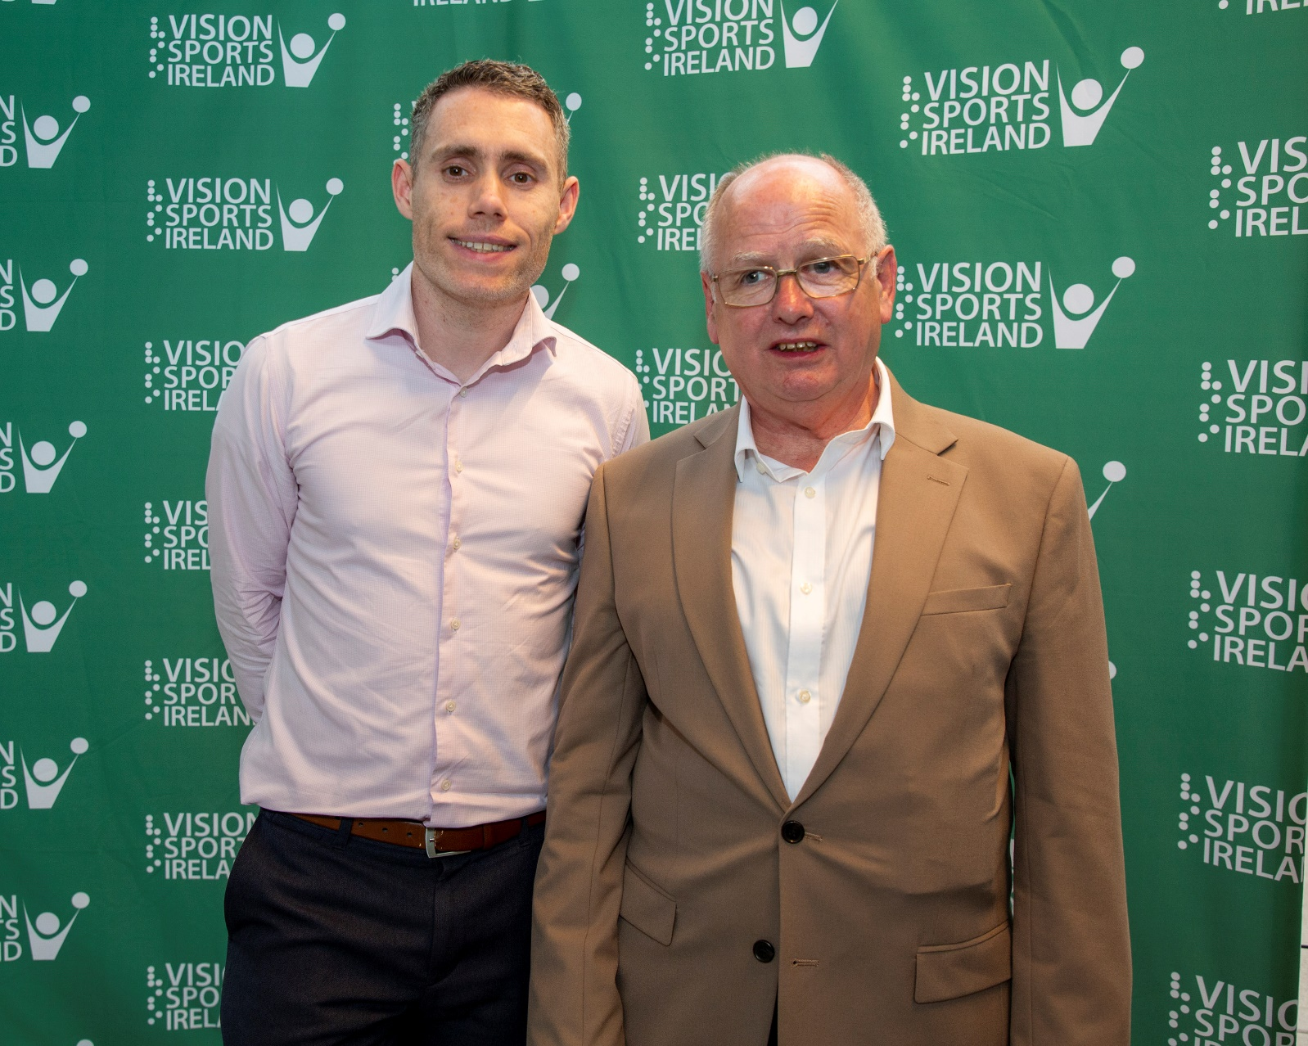

Joe Geraghty and former Paralympic athlete Jason Smyth at the launch of “Out of Sight”

## EDF Transport Accessibility Discrimination Database

Our friends and partners, EDF, have an important tool enabling people to report examples of disability in the use and access of transport.

We encourage you to [use this database](https://accessibility.edf-feph.org/) to make known all examples of discrimination in transport.

**ENDS**.

European Blind Union

6 rue Gager Gabillot, 75015 Paris, France

+33 1 88 61 06 60 | [ebu@euroblind.org](mailto:ebu@euroblind.org) | [www.euroblind.org](http://www.euroblind.org)