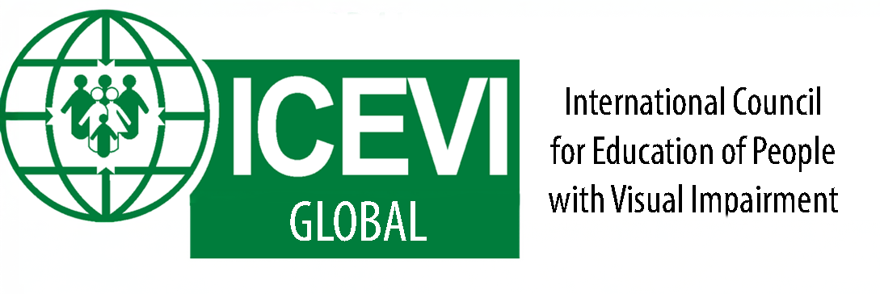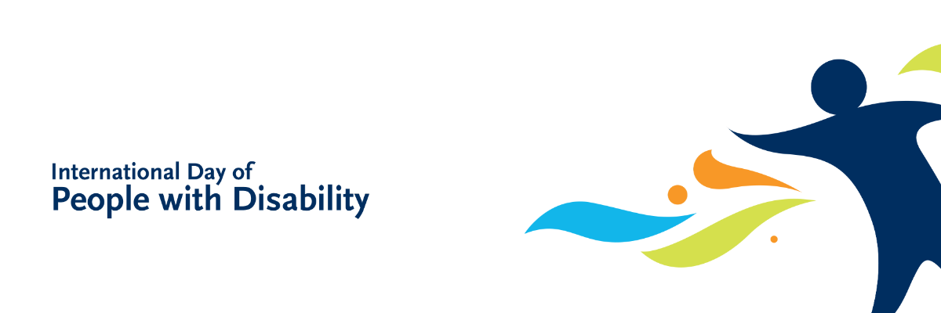

**FOR RELEASE ON DECEMBER 03, 2024**

**International Day of Persons with Disabilities 2024: *Amplifying the leadership of persons with disabilities for an inclusive and sustainable future***

Today, the International Council for Education of People with Visual Impairment (ICEVI) proudly unites with our international partners, global networks, and worldwide communities to mark the 2024 International Day of Persons with Disabilities (#IDPwD). Together, we call for the recognition of people with visual impairment, including those with blindness, partial sight, deafblindness, and additional disabilities as leaders. We advocate for their engagement at all levels towards enacting inclusive education, sustainable development, peace building, and climate action.

For more than 70 years, ICEVI has worked towards ensuring all people with visual impairment worldwide can access their right to an inclusive, equitable, and quality education.​ Education is the foundation for empowering people with visual impairment to be leaders in their own lives, their communities, and beyond. ICEVI works in partnership with people with visual impairment as leaders within and outside our networks to drive policies, strategies, and programs to realise the UN Sustainable Development Goals 4 (Education) and 10 (Reduced Inequality).

This International Day of Persons with Disabilities, ICEVI recognises the particular importance of ensuring that women, girls, and gender-diverse people with visual impairment can access education and leadership opportunities. ICEVI pledges to meet the key goals for IDPwD 2024 through co-designing approaches that amplify the leadership of all people with visual impairment:

* **Empowerment & Leadership**: Elevating the leadership of people with visual impairment, including youth, in shaping policies and programs that impact their lives, particularly in the areas of education, employment, and community development.
* **Inclusive Education**: Advocating for accessible, quality education for all people with visual impairment, ensuring they are equipped with the skills to lead in all aspects of life.
* **Global Policy Advocacy**:Highlighting the importance of integrating people with visual impairment into global frameworks, including the 2030 Agenda for Sustainable Development, the UNSC Resolution 2475 on Peace and Security,and the Sendai Framework for Disaster Risk Reduction.
* **Climate Action & Resilience:** Promoting the inclusion of people with visual impairment, especially youth, in climate solutions and disaster resilience efforts to ensure no one is left behind in the face of the climate crisis.

On this International Day of Persons with Disabilities 2024 and every day, ICEVI invites you to celebrate with us the many contributions of leaders with visual impairment around the globe, and to work together in partnership for an inclusive, just, and sustainable world, now and into the future.